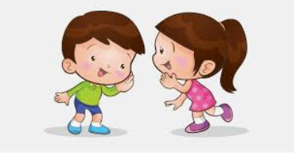
Talking to each other

- Look through the booklet together, talk about the adults and what to expect
- talk to them about meeting new people/ starting a new place and times when you have been worried/ scared and how you overcame it.
- don’t dismiss their feeling spend few minutes understanding how they are feeling.

Create a visual timetable
/ Social story
- talk about what the pictures are showing and their meaning
- talk about what you might do in a day and put them in order
- let the children play with the pictures and create a sequence of events

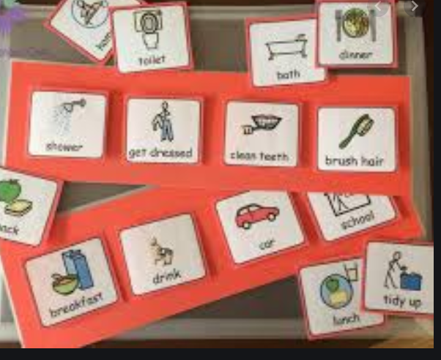

Have a sneaky peak!
- On your daily walk have a look
at the Nursery building from
the outside
- Talk about that you’re not far
from home and all the friends
you will make.
-
Changes

Transition into Nursery or Reception

Roleplay
- encourage the children to try on their uniform
- wear it for the morning or afternoon that they are attending
- complete some activities together i.e. reading a story, singing some stories, complete some games or jigsaw or play with their favourite toy.
- talk about what they are looking forward to, what they think they maybe doing at Nursery/ Reception
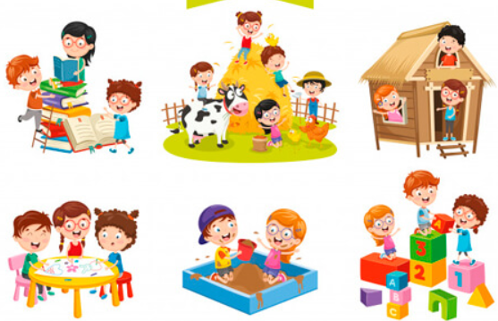

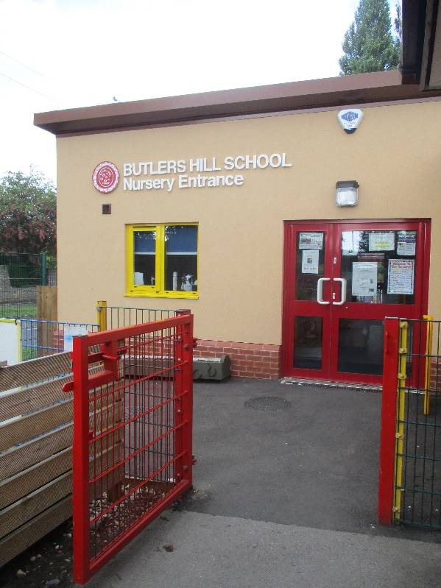

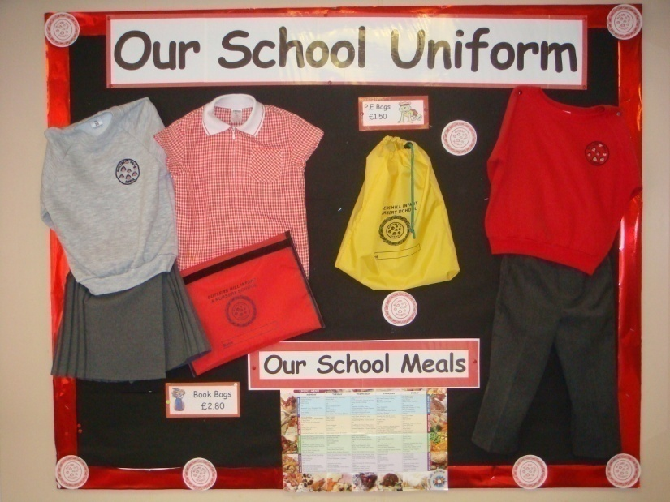

Starting school books
https://www.youtube.com/watch?v=1zQivaCXu-Q – starting school
https://www.youtube.com/watch?v=gCR42DG1joU – Harry and the dinosaurs go to school
https://www.youtube.com/watch?v=qeDtSyhKi8o – chu’s first day at school
https://www.youtube.com/watch?v=KnT5MDZ5SGc – first day at bug school
https://www.youtube.com/watch?v=imG2EW2wlkk – I am absolutely too small for school
Learn some nursery rhymes and songs

https://www.bbc.co.uk/teach/school-radio/nursery-rhymes-a-to-z-index/z4ddgwx



