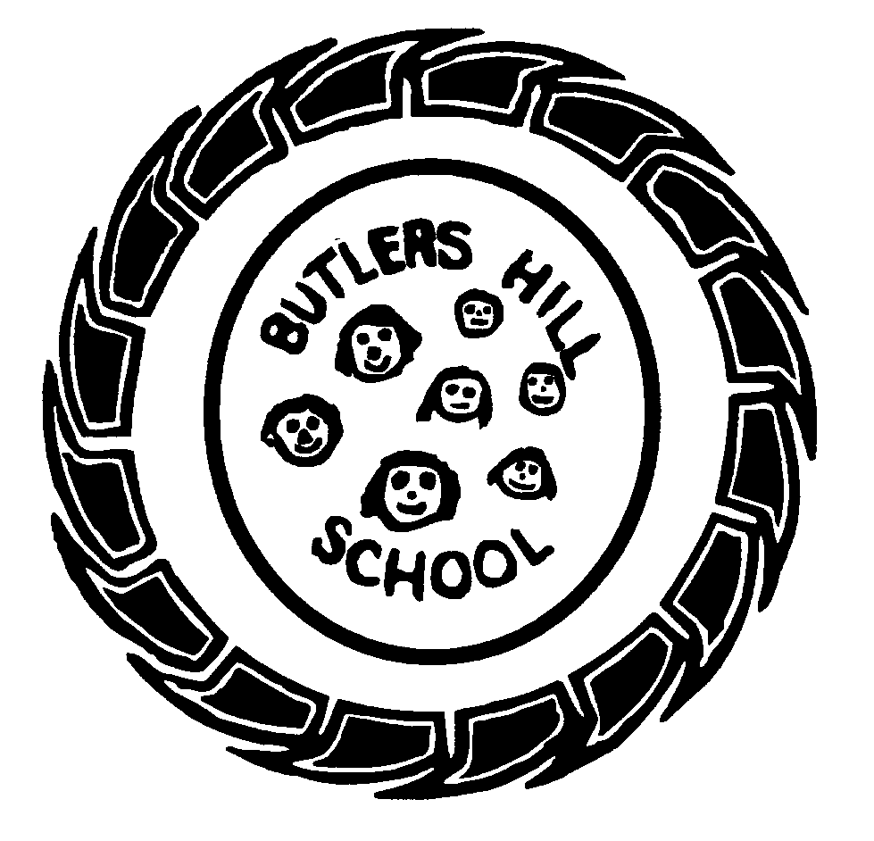

F2 Long Term Goals
At Butler’s Hill we…Dream Big, Aim High Aims: Caring, Creative, Confident
CLL    Curious Chatterbox | PSED    Sparkly Star | Life Skills  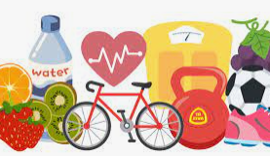 | Gross Motor Skills  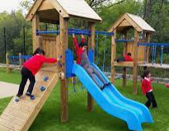  Confident Risk Taker
To become a ‘Curious Chatterbox’ who can listen carefully, ask relevant questions and make comments, chat back and forth with friends and adults and express ideas and feelings with confidence. | To become a ‘Sparkly Star’ who is kind, caring and confident sand shows empathy to others, determination to complete a goal, resilience in the face of challenges and develops a love of learning. | To become a ‘ Confident citizen’ who can put on their own coat, go to the toilet, make healthy choices and enjoy being independent. | To become a ‘Confident Risk Taker’ who can use strength, balance and co-ordination to run, jump, hop, skip and climb confidently and safely, using the climbing frame, vehicles, digging and large construction.
Fine Motor Skills  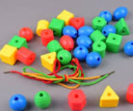  Talented Tool User | Phonics  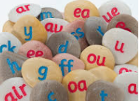  Fabulous Phonics Extraordinaire | Reading    Book worm | Writing    Sentence Superstar
To become a ‘Talented Tool User’ who holds a pencil effectively and uses scissors and other tools with confidence. | To become a ‘Fabulous Phonics Extraordinaire’ who can use sounds to read books containing words they can decode and can write | To become a ‘Book Worm’ who reads for pleasure, has a love of reading and builds a bank of favourite books using texts as an open door into a world of possibilities. | To become a ‘Sentence Superstar’ who can write phrases and sentences (containing single sounds and digraphs) that other people will enjoy reading.
Maths    Deep Sea Number Diver | The World  Exceptionally Eager Explorer | Art    Creativity Expresser | Music/Dance  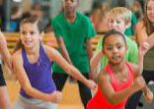  Passionate Performer
To become a ‘Deep Sea Number Diver’ who has a deep understanding of numbers to 10, who can recognise the pattern of the counting system, compare quantities and who can recall number bonds to 5 in a flash! | To become an ‘Exceptionally Eager Explorer’ who has an eager and inquiring mind and who understands how to read a simple map, can talk about their family, shows care to living creatures and understands some differences between our country and others. | To become a ‘Creativity Expresser’ who loves to be creative and is able to develop their own ideas using learnt skills, techniques and knowledge of experiences and artists to represent their personal creative style. | To become a ‘Passionate Performer’ who enjoys performing a story, song, poem or rhyme to an audience.

