

Butlers Hill Infant and Nursery School - Long Term Plan - Year 2
 | Autumn 1 | Autumn 2 | Spring 1 | Spring 2 | Summer 1 | Summer 2
School Aims School Values British Values
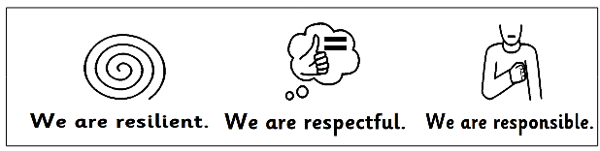

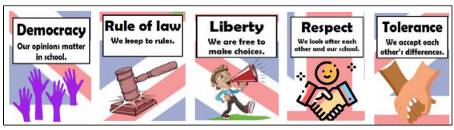

Topic:  Dream Big, Aim High | Where in the World am I?    I am Geographer | Why was the fire so Great?  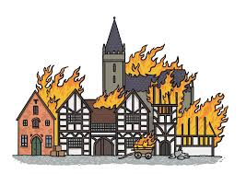  I am an Historian | Why save the rainforest?  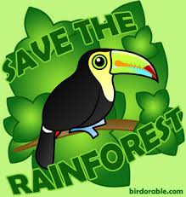  I am an Eco-Warrior | Who was Mary Seacole?  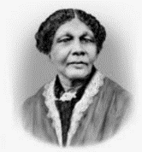  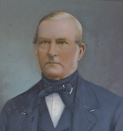  I am a nurse | Where will we go?    I am an Explorer | Could you survive Medieval Britain?  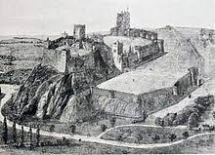  I am knight
Immersing / Role Play | Airport | Bakery- london street | Rainforest village | Hospital |  | Medieval banquet
Enrichment | Visit to the Brooke farm in Linby | Drama workshop around the Great Fire | Zoo Lab-with Amazon minibeasts | Florence Nightingale / Mary Seacole workshop | University visit | Visit to Castle / Sherwood Forest  Cinema visit
Community Links  Parent Engagement | Parent Welcome Meeting  Jumble Sale  MacMillan Coffee Morning  Gold Book Award  Big Read | Gold Book Award  Big Read | Gold Book Award  Big Read | Gold Book Award  Big Read | Gold Book Award  Big Read | Summer Fair  Gold Book Award  Big Read
Key Events | Harvest Festival | Remembrance Day  Diwali/Bollywood  Children In Need  Anti Bully Week | Internet Safety Day | World Book Day  Comic/Sports Relief | Healthy Living Week | Transition  Sports Day  Leavers Concert
Healthy Living | 30 Active Minutes - daily | 30 Active Minutes - daily | 30 Active Minutes - daily | 30 Active Minutes – daily | Walk to School Week  30 Active Minutes - daily | 30 Active - Minutes daily  Healthy Living Week
 | Autumn 1 | Autumn 2 | Spring 1 | Spring 2 | Summer 1 | Summer 2
Writing Units | 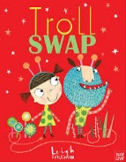  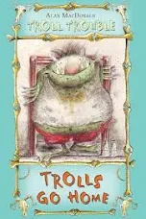 | 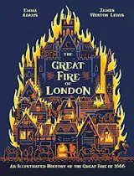 | 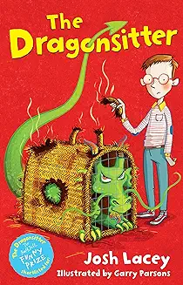  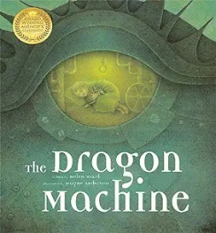 | 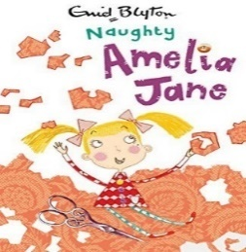  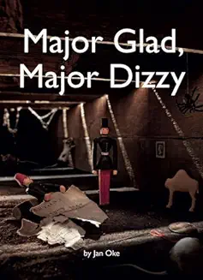 | 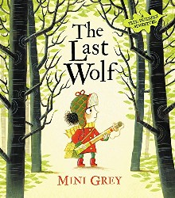 | 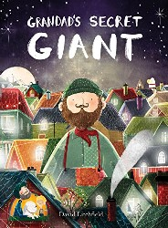
Author  Outcome: | Troll Swap by Leigh Hodgkinson/Trolls Go Home by A. MacDonald  Story – character focus | The Great Fire of London by E. Adams and J.W-L  Write a fact sheet | Dragon Machine by H. Ward/The Dragonsitter by J. Lacey  Adventure story | Major Glad, Major Dizzy by J. Oke,/ Naughty Amelia Jane by Blyton  Diary entry | The Last Wolf  by Mini Grey  Letter | Grandad’s Secret Giant by David Litchfield  Moral Story
Geography  (3 units)  &  History  (3 units) | Geography | History | Geography | History | Geography | History
Geography  (3 units)  &  History  (3 units) | Where in the World am I?  The UK  Continents and oceans,  Wider world   | The events of the Great Fire of London – ordering, learning through eye witness accounts, comparison of London then and now | Locations and climates of a rainforest. Human and Physical features. Deforestation and a comparison of life in Brazil and UK. | The study of Mary Seacole / Florence Nightingale  Local Healer:  Who was Zachariah Green? | 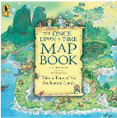  Unit on Maps / mapping skills | Medieval Britain & Nottingham  What was life like for people in the past and how does it compare to life now?  How has Nottingham changed.
Science  (White Rose) | Working Sc  Create bird feeders to hang in grounds (hwk)  Explore a fish, identifying its fins, scales and gills  Sort and group small figures of 5 different classification groups | Humans  Describe the importance for humans exercise, eating the right amount of different types of food and hygiene  Exercise stations (PE session)  Sorting and grouping food item and packaging and classifyi8ng them.  Germs-experiment  ASSESS ANIMALS I8NCLUDING HUMASN  Materials  Identify and compare the suitability of variety of everyday materials, including wood, metal, plastic, glass, brick, rock, paper and cardboard for particular uses.  Material Hunt in the classroom  Material Hunt at Home  Explore changing shape | Plants (light and dark)  Find out and describe how plants need water, light and suitable temperature to grow and stay healthy.  Plant a plant of their own  Plant in the light and Plant in the dark and light  Investigate in the local area to plant hunt- HWK | Living things and their habitats  Identify that most living things live in habitats to which they are suited and describe how different habitats provide for the basic needs of different kinds of animals and plant and they depend on each other.  Classifying animals depending on their habitat  HWK-find things that are alive, never been alive, was alive  Visit bug hotel in Forest School | Plants (bulbs and Seeds)  Observe and describe how seeds and bulbs grow into mature plants  Dissect different fruits and veg to observe the seeds  Growing up  Notice that animals including humans have offspring that grow into adults.  HWK-Can you find a grown up to share photos with you of them as a bay, toddler, teenager, adult or them as a baby, toddler and now  Butterflies experiment and observation | Scientists and Inventors  Looking at wind turbines, greenhouses, doctors, botanists and ocean pollution through experiments and looking at historical famous people.
Maths  White Rose | Place Value (x3 weeks)  Addition  Subtraction | Addition as the inverse of subtraction  Grouping & repeated addition  Multiplication using arrays  Fractions | Place Value  Division (2 weeks)  Fractions | Time  Addition and subtraction  Measures  Revision for KS1 assessments | Addition and subtraction  KS1 Assessments  Shape & Position  Data Handling | Odd and even numbers  Estimation  Seasons / Time  Time  Reading scales  Fractions
PSHE / SRE | Being in My World | Celebrating Difference | Dreams and Goals | Healthy Me | Relationships | Changing Me
RE | Jewish celebrations, artefacts & places of worship | The Christmas story  The celebration of Eid | Jewish celebrations and stories | Easter Story | Jesus’ friends & bible stories | Jewish stories
Art  &  DT | DT | Art | Art | DT | DT | Art
Art  &  DT | Food Technology  Food hygiene, health and safety cutting skills, design & evaluate, product testing, | Jan Griffer  Landscape artwork based on work of Jan Griffer’s Great Fire of London – lines and textures,  sketching with oils/pastels. | Henri Rousseau  Creating a rainforest scene based on Henri Rousseau’s work – colour mixing, sketching and collage | Wheels & Axels – making an emergency vehicle  Testing existing products, designed to fit a set criteria, using axels, building and designing. | Textiles – a bag for Little Red  Skilled lessons on how to do a running stitch, evaluate existing products, testing out functionality, design and making. | Sculpture: Linked to Grandads Secret Giant
ICT | Coding | Spreadsheets  Online Safety | Creating pictures and impressionist art | Questioning | Making Music | Effective Researching and presenting ideas
Music  (Charanga) | Hands, Feet, Heart | Ho Ho Ho | I Wanna Play in a Band | Zootime | Friendship Song | Reflect, Rewind and Replay  Leavers Production: using our voices expressively to learn and rehearse songs.
PE  (Complete PE) | Gymnastics  Ball skills | Gymnastics  Ball skills | Dance  Ball Skills | Dance  Locomotion | Games  Locomotion | Ball Skills  Team Building

