PLEASE supervise children if they are accessing the internet https://www.childnet.com/parents-and-carers/hot-topics/keeping-young-children-safe-online
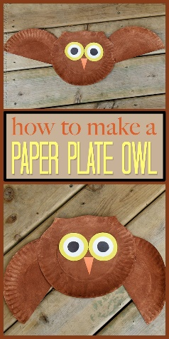
Picnic on the moon:

Create your very own picnic to take to the moon with you. What delicious foods will you make and how will you create your moon environment?
Can you remember the owl from the story?
Why don’t you have a go at making your very own
best friend Owl.
3D Rockets:
Can you have a go at making your own rockets to get to the moon? Take a look at some ideas below
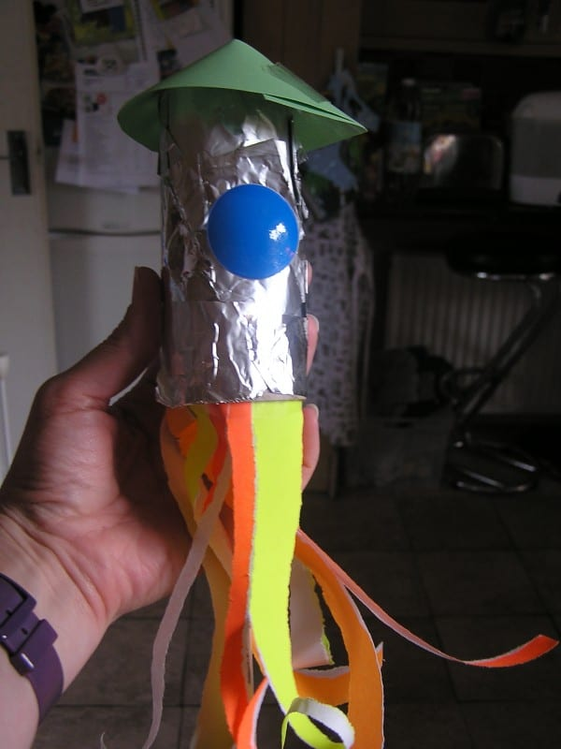
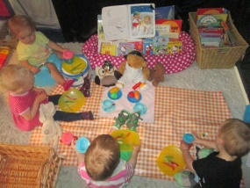
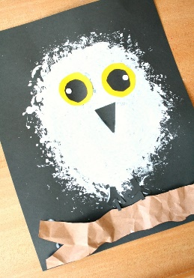
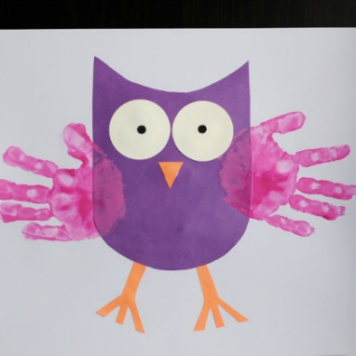
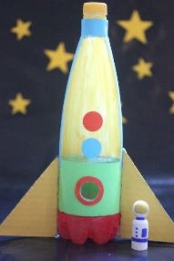
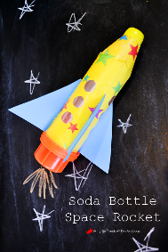
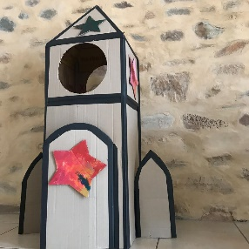

Spacy playdough activity:

Whatever Next
By
Jill Murphy
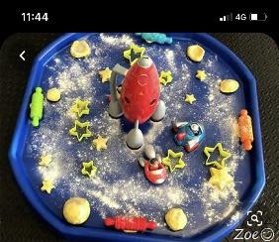
Take a look at some of the other stories below by the Author Jill Murphy… you might recognise some of the books from nursery. Which one is your favourite?

Peace at Last
https://www.youtube.com/watch?v=9U9y35kWBvM

Mother Knows Best
https://www.youtube.com/watch?v=UbgRkX-ZtmQ

On the Way Home
https://www.youtube.com/watch?v=URRAMHToe4s

A Quiet Night In
https://www.youtube.com/watch?v=jC_Po3VS3IQ

Meltdown
https://www.youtube.com/watch?v=ZJUVfGQWMyA

Do you have an old cardboard box and a sieve? Can you recreate the story using props from home and language from the book?

https://www.youtube.com/watch?v=m0XQ9YhWd_Y

Have another listen to the story
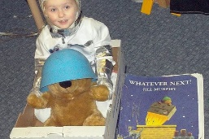

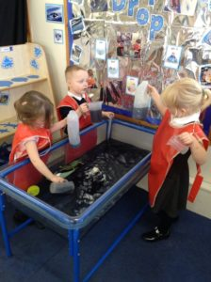
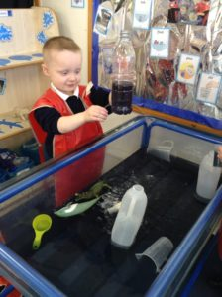
Black Moon Water
Tipping
Pouring
Splashing

What do we know about space? Let’s investigate more and see if we can spot the moon from the story… and Earth where we live. Can you hear the name of any other planets in the solar system?
https://www.youtube.com/watch?v=Qd6nLM2QlWw

Discussions: Take a look outside when it gets dark. Maybe you could think about discuss some of the topics below.
What can you see? How many stars can you count? How far away do you think the moon is? Where do stars come from.


