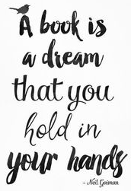
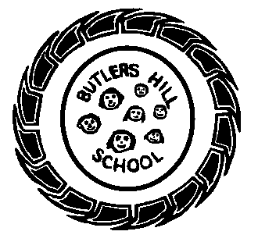

Butler’s Books
Autumn 1 2020 – Our Reading Newsletter
Edition 1 completed by the Year 2 Team

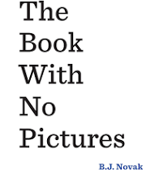
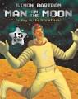
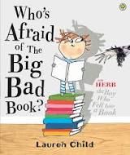
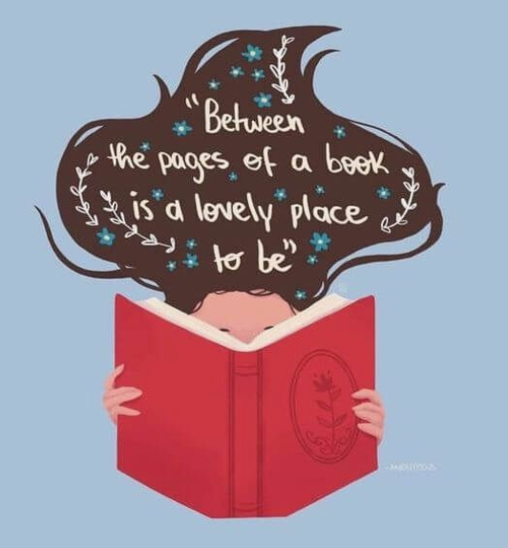
An interview with: Mrs Amos
What’s your favourite book & why?
Big hair, don’t care by Crystal Swain Bates. The message promotes positive self esteem & celebrations all our amazing differences.
Book or Kindle?
Definitley the kindle – I can make the text supersize!
Where do you most like to read?
In my conservatory – a peaceful space to relax and unwind.
Welcome to our first reading newsletter of the year. We are so excited to share with you what we’re currently reading, our favourite book recommendations, tips for reading & what we’re doing to promote a love of reading within our school community.
Mrs Siddons says:
“It looks alittle boring from the cover but wow this book gets my class and I belly laughing!! The reader is made to say & do lots of funny things”

Alfie S from Y2b says:
“You will love the pictures in this books – the little aliens pop up everywhere, it’s so funny”

Please remember to sign your child’s home-school diary. It promotes the importance of reading and is a lovely way to spend some time with your child at the end of a busy day. Let us know what they’ve read or even what you’ve read to them! Take it in turns, ask each other questions and explore picture books. We have plenty in school, the local library is a wonderful resource and charity shops are an amazing place to find as good as new books.
I love reading because….
“books help me learn new things. I didn’t know it before but then I do after reading a book” – Devon 2b
“it’s awesome” – Ross 2a
“it’s so important” – Connie 2a
“it’s fun” – Rue 2c
“it’s enjoyable” – Nana 2b
Need inspiration?
Use these websites for some great book recommendations:
- www.padlet.com
- www.booksfortopics.com
- www.booktrust.org
Check out the bestsellers on:
- Amazon
- Waterstones
- The works

Miss Beldham says:
“I love reading this story to my class. The children are engrossed from beginning to end. There are so many traditional tales all wrapped up in one laugh out loud story”
Year 2’s recommended reads:
What we’re reading in school this half term:
F1 – Dear Zoo by Rod Campbell
F2 – The gruffalo by Julia Donaldson
Y1 – Michael Recycle by Ellie Bethel
Y2 – The paper dolls by Julia Donaldson

