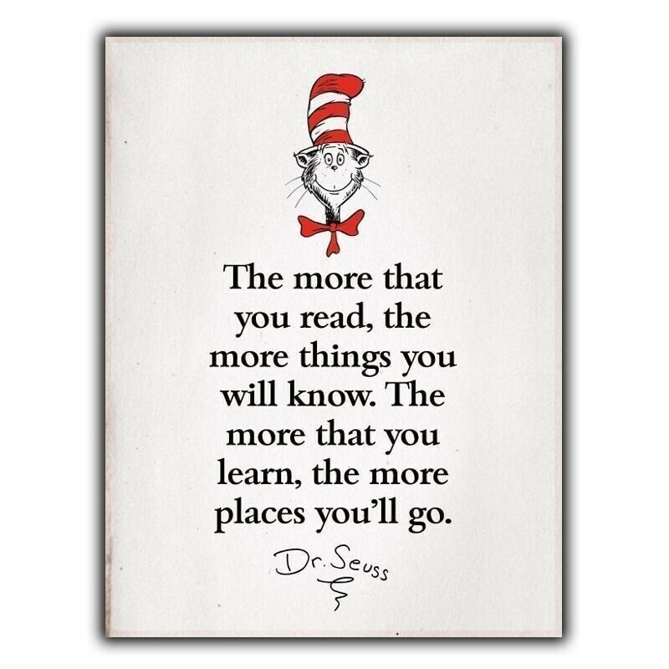
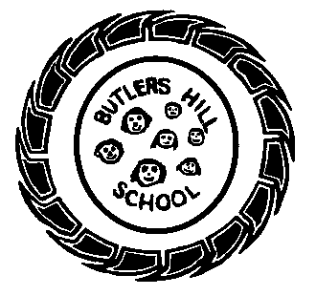
Butler’s Books
Autumn 2 2020 – Our Reading Newsletter
Edition 1 completed by the Year 1 Team

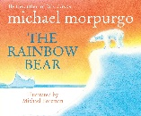
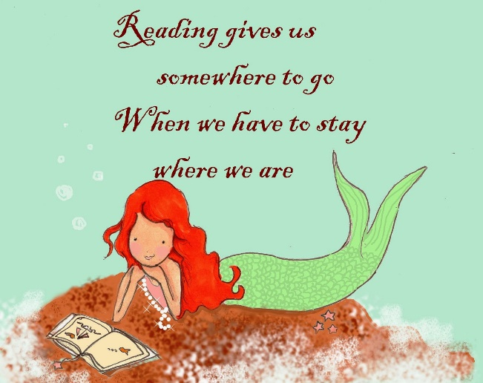
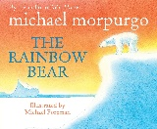
Mrs Radford says: This half term I would recommend Wonky Donkey – Craig Smith. It’s all about a donkey with plenty of rhyming and places for the children to join in by predicting the words as you read.
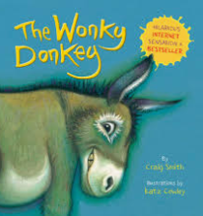
Miss McIntyre says: This half term I would recommend Rainbow Bear – Michael Morpurgo. It’s all about accepting yourself and knowing that change isn’t always the best option!

Mrs Castle says:
This half term I would recommend Big Bear Little Brother. This book is all about the friendship between a polar bear and a lost little boy. I always like a good book about friendship!
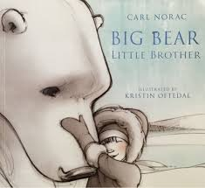
I love reading because….
“It makes me happy” A.R
“It helps me calm down” S.B
“I learn new words” K.H
It gives me some quiet time” CK
“I like getting to hard words” T.W.
“I like the pictures” C.H
Need inspiration?
Use these websites for some great book recommendations:
- www.padlet.com
- www.booksfortopics.com
- www.booktrust.org
Check out the bestsellers on:
- Amazon
- Waterstones
- The works

An interview with: Mrs Castle
What’s your favourite book & why?
I have lots of books I like, books I read as child, books I have read to my children and books that have just got a great front cover! As a child my favourite book was The Far Away Tree by Enid Blyton. It was a big hardback book with amazing illustrations.
Book or Kindle?
Definitely a book so that I can flick back quickly and double check what I have read!
Where do you most like to read?
I like to read in bed with a hot chocolate and lots of pillows.

Welcome to our second reading newsletter of the year. We are so excited to share with you what we’re currently reading, our favourite book recommendations, tips for reading & what we’re doing to promote a love of reading within our school community.
Zach’s recommendation from home!
1A loved this book!

Please remember to sign your child’s home-school diary. It promotes the importance of reading and is a lovely way to spend some time with your child at the end of a busy day. Let us know what they’ve read or even what you’ve read to them! Take it in turns, ask each other questions and explore picture books. We have plenty in school, the local library is a wonderful resource and charity shops are an amazing place to find as good as new books.
Year 1’s R ecommendations


