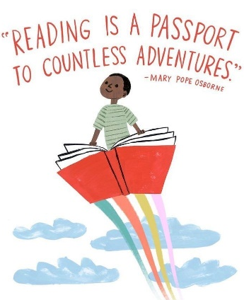
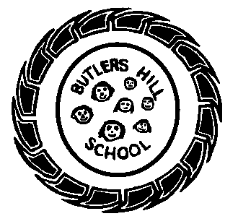
Butler’s Books
Spring 2 2021 – Our Reading Newsletter
Edition 3 completed by the Foundation 2 Team.

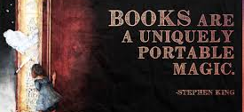
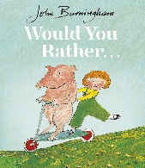
Please remember to sign your child’s home-school diary. It promotes the importance of reading and is a lovely way to spend some time with your child at the end of a busy day. Let us know what they’ve read or even what you’ve read to them! Take it in turns, ask each other questions and explore picture books. We have plenty in school, the local library is a wonderful resource and charity shops are an amazing place to find as good as new books.
Mrs Southey says: “It is a book about a special fish with shimmering scales. I like it because the pictures are glittery and shiny and has a message about selfishness and sharing!”
Need inspiration?
Use these websites for some great book recommendations:
- www.padlet.com
- www.booksfortopics.com
- www.booktrust.org
Check out the bestsellers on:
- Amazon
- Waterstones
- The Works

An interview with: Mrs Elkington
What’s your favourite book & why?
My favourite book is ‘Would you rather’ by John Burningham because I remember reading it with my mum when I was little and you can choose what you would rather do or be on each page!
Book or Kindle?
Book
Where do you most like to read?
In bed before I go to sleep!

Recommendations from home
F2 A – Etienne likes ‘How to Draw a Dinosaur’ because it has a spineosaurus.
F2 B – Niamh enjoys ‘Stickman’ by Julia Donaldson because he finds his family at the end and has a happy Christmas.
F2 C - Henry enjoys ‘Octopants’ by Suzy Senior he says its really funny!
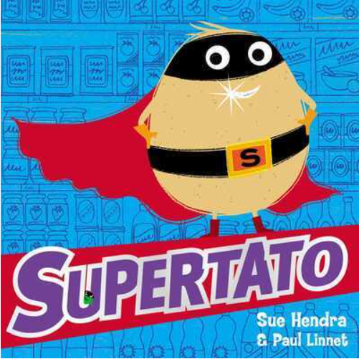
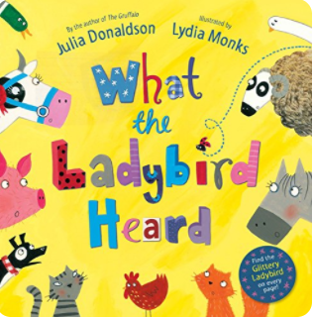
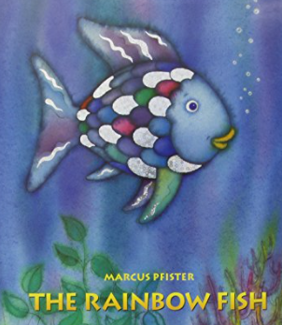
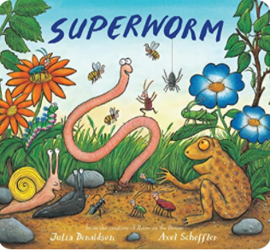
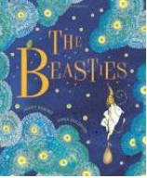
I love reading because….
“I can read what my game says and tells me what to do!” – Etienne F2A
“It is good for me” – Elise F2A
“It helps me sleep” – Arjun F2B
“We read as a family” – Emilia F2C
“I can read with my sister” – Poppy F2C
Welcome to our third reading newsletter of the year. We are so excited to share with you what we’re currently reading, our favourite book recommendations, tips for reading & what we’re doing to promote a love of reading within our school community.
Miss Mee says: “All the animals on the farm are noisy except the ladybird who never says a word. But when two bad men come to steal from the farm, the ladybird knows exactly what to do to help her friends.”

Mrs Cunnington says: “This book is about a little girl who uses little treasures, such as buttons, to gives her ideas for writing stories. I like little treasures and I would enjoy making up stories to go with them.”

Miss Carrington says: “I love Supertato because he is a superhero and loves saving the vegetables from the Evil Pea!”
F2’s recommended reads:
Mrs Akpovi says: “This book always has the children and I fully engrossed! Joining in with the fun rhymes and song, hip hip hooray for Superworm!”

