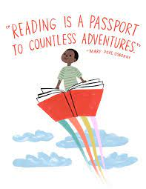
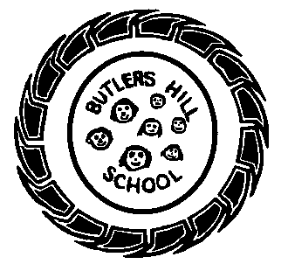

Butler’s Books
Summer 1 2020 – Our Reading Newsletter
Edition 4 completed by the Year 2 Team

We are so excited to share with you what we’re currently reading, our favourite book recommendations, tips for reading & what we’re doing to promote a love of reading within our school community.
Mrs Siddons says:
“Our class loved this story by Tom Pervical, in fact we are loving all of his books, however this one stood out as we were able to make our own worry monster to share our worries together.”

Please remember to sign your child’s home-school diary. It promotes the importance of reading and is a lovely way to spend some time with your child at the end of a busy day. Let us know what they’ve read or even what you’ve read to them! Take it in turns, ask each other questions and explore picture books. We have plenty in school, the local library is a wonderful resource and charity shops are an amazing place to find as good as new books.
Y2 top authors!
- Oliver Jeffers
- Tom Percival
- David Walliams
- Julia Donaldson
- Cressida Cowell

Need inspiration?
Use these websites for some great book recommendations:
- www.padlet.com
- www.booksfortopics.com
- www.booktrust.org
Check out the bestsellers on:
- Amazon
- Waterstones
- The works

Mrs Wallis says:
“I have been reading this story with my little girl at home and we both love the pictures! It’s about a little boy who shares an extra special bond with his dog – another fab story by Julia Donaldson
Year 2’s recommended reads:
What we’re reading in school this half term:
F1 – The enormous turnip
F2 – Aaaarrgghh Spider! By Lydia Monks
Y1 – A range of WW2 topic books
Y2 – Jack and the Beanstalk

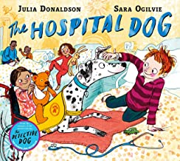

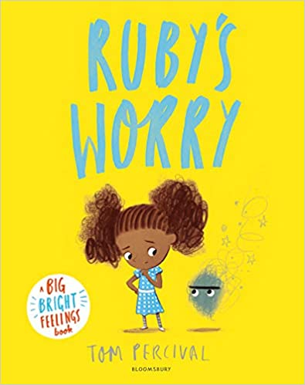
An interview with: Miss Beldham
What’s your favourite book & why?
My favourite children’s book is probably the heart and the bottle by Oliver Jeffers – its just magical. I am also partial to a Harry Potter book too!
Book or Kindle?
Definitely a book! I prefer to have the book in my hand & when reading children’s books its great to look at the pictures too.
Where do you most like to read?
I would say on the beach!! Preferably one where the sun is shining. But if not I would say whilst having a relaxing bath.

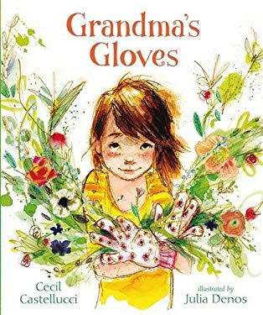
Harper from Y2b says:
“I love sharing this book with my mummy. The ending is my favourite as it shows you that the girl learnt everything she knew from her grandmother.



