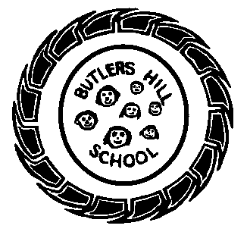
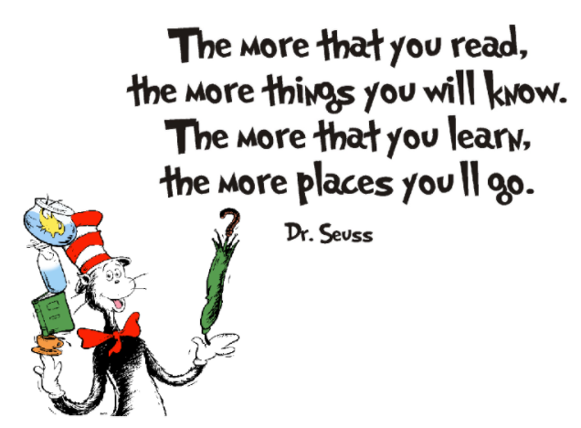
Butler’s Books
Summer 2 2021 – Our Reading Newsletter
Edition 6 completed by the Nursery Team.

Nursery’s recommended reads:
Welcome to our sixth reading newsletter of the year. We are so excited to share with you what we’re currently reading, our favourite book recommendations, tips for reading & what we’re doing to promote a love of reading within our school community.
Please remember to sign your child’s home-school diary. It promotes the importance of reading and is a lovely way to spend some time with your child at the end of a busy day. Let us know what they’ve read or even what you’ve read to them! Take it in turns, ask each other questions and explore picture books. We have plenty in school, the local library is a wonderful resource and charity shops are an amazing place to find as good as new books.
I love reading because….
“They’re exciting. I like reading them…. Some of my books are exciting because the characters make funny noises” “I like Rumpelstiltskin because at the end he goes all read and stomps away” TH
“I like reading Boris because Boris is so Funny, he likes to eat me. I read books to Harper” JT
“Books have lots of words and some make noises. Ive got a big princess book and it has lots of Princesses in it….. you can learn letters” LW
“… theres interesting things in them. Ive got pop up books at home and they’re funny. I read them all the time. You can learn numbers in books” FRB

Miss Parkin “I used to read this book to my children when they were younger and we used to like the happy ending. Mr Big is lonely; he’s really big and that can scare some people, but during the book he makes lots of new friends and isn’t lonely anymore“.

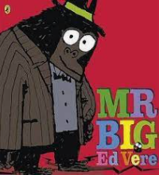
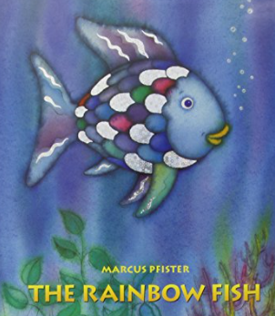
Mrs Richards says: “It’s about an adventure that a balloon goes on after it is found – it is magic! It changes its shape, colour, size and a lot more. I used to have fun playing games with a balloon with my brothers and sister like ‘keepy upy’ and blowing it up”. and letting it go!“
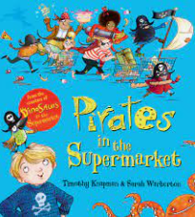
Miss Draper says: “I like the rhyming words and looking for the pirates hiding. Me and Jonah like to go to Tesco and try to spot any pirates that might be hiding”.

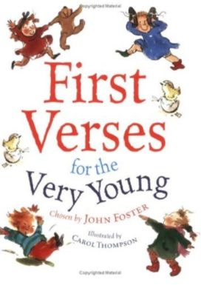
An interview with: Miss Chumun
What’s your favourite book & why?
‘First verses for the very young’ because when my eldest was younger she used to love the different poems especially the one about bubblegum popping all over the boys face!
Book or Kindle?
Books definitely! I like the feel of a book in my hands, turning the pages and flicking back and forth to re-read, even having a sneaky look at the end!.
Where do you most like to read?
Snuggled up on my settee with a
cup of tea as I tend to fall relax
and asleep if I read in bed!
Recommendations from home
‘The Cave’ by Rob Hodgson – EL
‘Funnybones’ by Janet & Allan Ahlberg - JT
‘Tiddler’ by Julia Donaldson – TH
‘The runaway Pea by Kjartan Poskitt – HG
‘First Dictionary’ - R

Need inspiration?
Use these websites for some great book recommendations:
- School list for the Early Years
- www.padlet.com
- www.booksfortopics.com
- www.booktrust.org
Check out the bestsellers on:
- Amazon
- Waterstones
- The Works

Miss Chumun says: “After such a difficult couple of years for everyone I love this book. It reminds me of how we came together in difficult times and that if we support each other we can get through most ‘rainstorms’ that we experience in life“.


