Butlers Infant School Progression in Written Addition (Written in collaboration with Broomhill Junior School) | Stage 1 (From Reception and Y1)  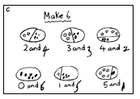  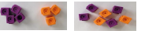  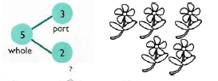  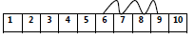  Children are taught that addition is the combining of two or more amounts. They begin by counting all of the items in the groups, then move on to counting on from the largest amount. Children are encouraged to develop a mental image of the size of numbers. They learn to think about addition as combining amounts in practical, real life situations.  They begin to record addition number sentences such as  2 + 4 = 6 and 8 = 3 + 5 and 3 + 2 + 4 = 9 | 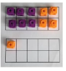  Stage 2 (From Y1/2)  Children move on to using Base 10 equipment and ten frames to support their developing understanding of addition.  11 + 5 = 16  11 cubes are lined up (1 ten and 1 unit/one).  5 cubes are added to the line of 11 giving a total of 16.  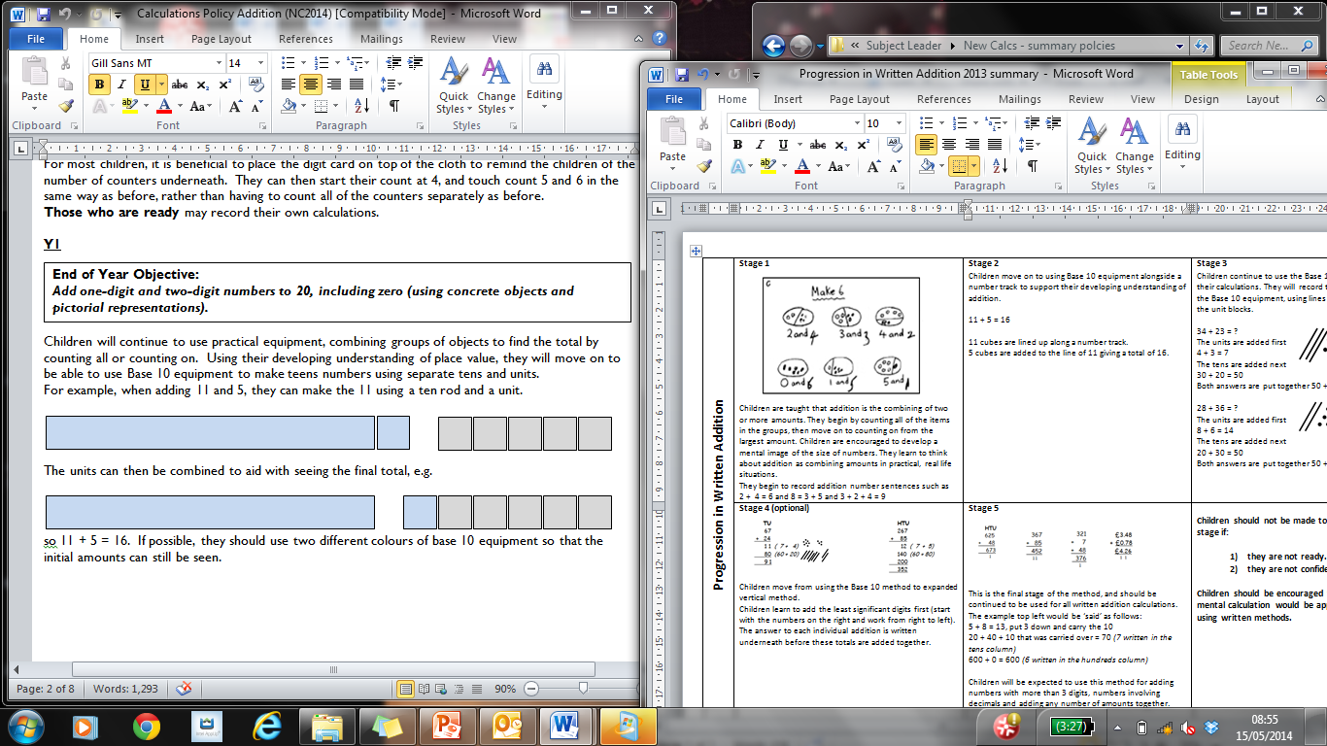  If possible, use two different colours of base 10 equipment so that the initial amounts can still be seen. | Stage 3 (From Y2/3)  Children continue to use the Base 10 equipment, ten frames and other practical resources to support their calculations, including exchanging 10 units/ones for 1 ten when the total of the units/ones is 10 or more. They will record their own drawings, using lines for 10 rods and dots for the unit blocks.  34 + 23 = ?  The units/ones are added first 4 + 3 = 7  The tens are added next  30 + 20 = 50  Both answers are put together 50 + 7 = 57  28 + 36 = ?  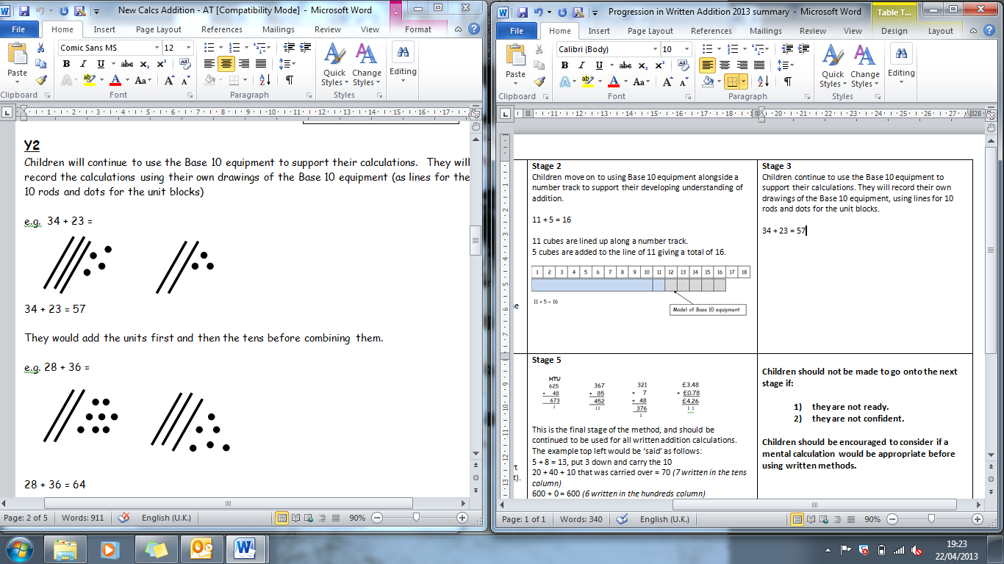  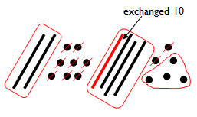  The units/ones are added first  8 + 6 = 14 with ten units/ones exchanged for 1 ten.  A ring is put around the units/ones not exchanged – this is the units part of the answer. The tens are then added, including the exchanged ten, to complete the sum.
 | 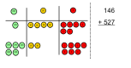  Stage 4 (From Y3/4)  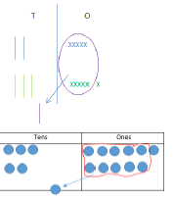  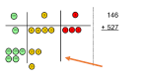  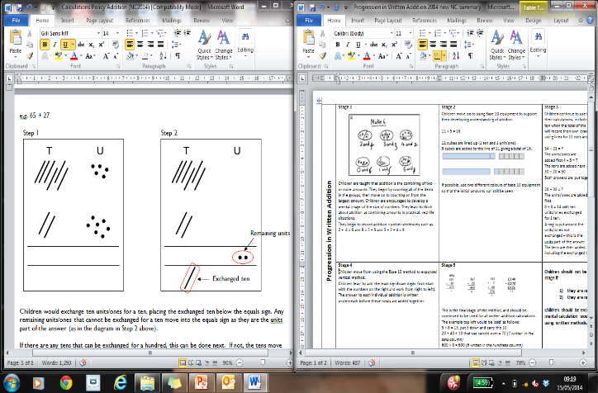  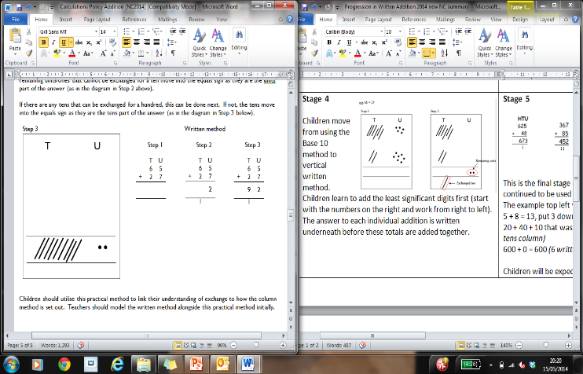  65 + 27  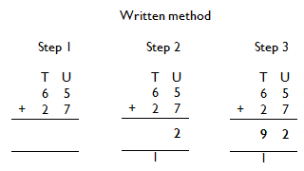 | 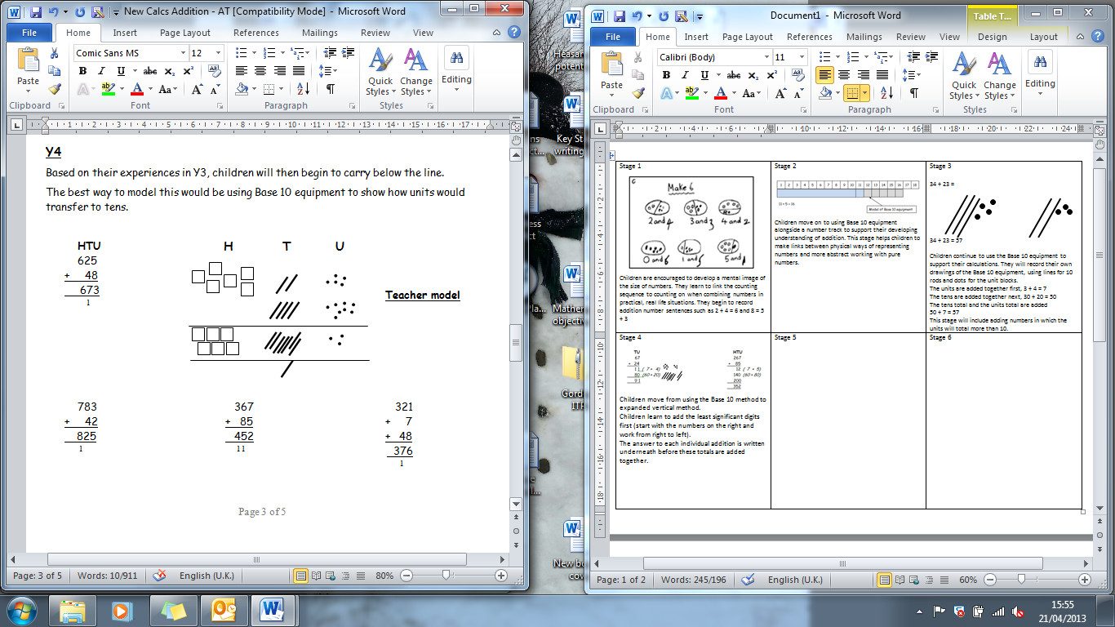  Stage 5 (From Y4 onwards)  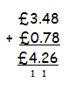  This is the final stage of the method, and should be continued to be used for all written addition calculations.  The example top left would be ‘said’ as follows:  5 + 8 = 13, put 3 down and carry the 10  20 + 40 + 10 that was carried over = 70 (7 written in the tens column)  600 + 0 = 600 (6 written in the hundreds column)  Children will be expected to use this method for adding numbers with more than 3 digits, numbers involving decimals and adding any number of amounts together. | Children should not be made to go onto the next stage if:  - they are not ready.  - they are not confident.  Children should be encouraged to consider if a mental calculation would be appropriate before using written methods.

