Butlers Hill Infant School Progression in Written Subtraction (Written in collaboration with Broomhill Junior School) | Stage 1 (From R and Y1)  Children will subtract two numbers by taking one away from the other and counting how many are left.  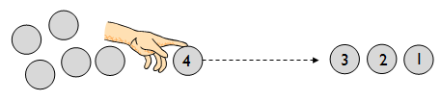  Children are encouraged to develop a mental image of the size of numbers. They learn to think about subtraction as ‘take away’ in practical, real life situations.  They begin to record subtraction number sentences such as  8 – 5 = 3  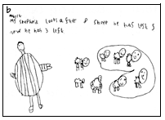 | Stage 2 (From Y1/2)  Children move on to using Base 10 equipment and ten frames alongside a number track to support their developing understanding of subtraction.  13 - 4 = ?  13 cubes are lined up.  4 cubes are removed from the end of the line leaving 9 left.  It is important that children keep track of how many have been removed.  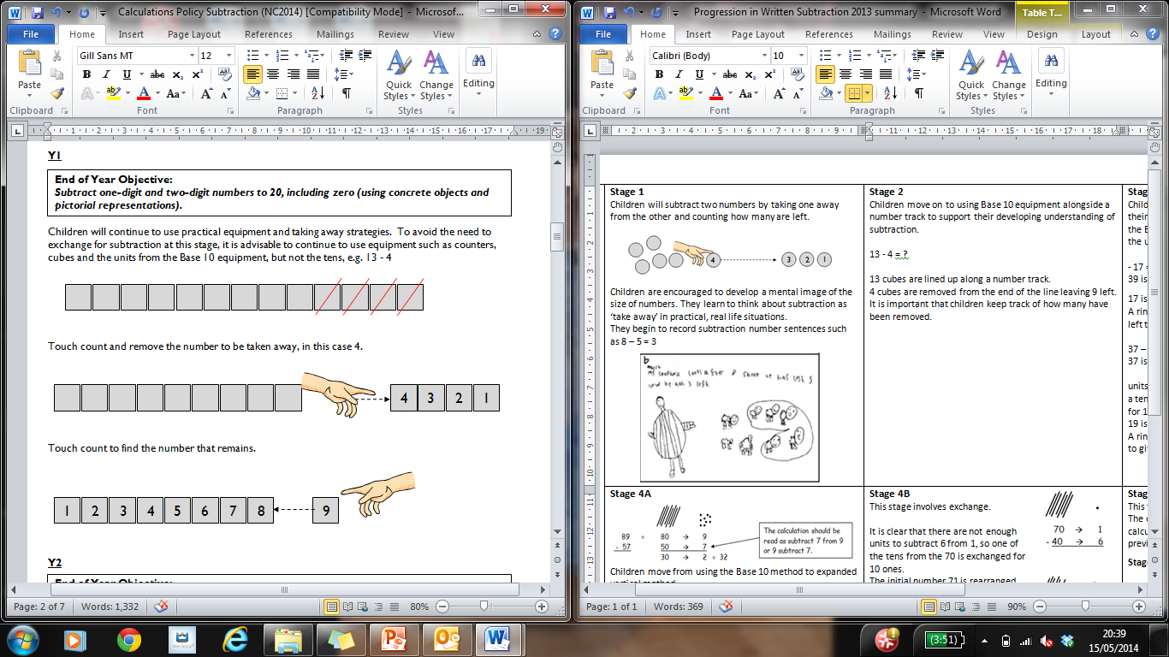  Touch count and remove the number to be taken away.  Touch count to find the number that remains.  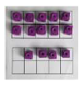 | Stage 3 (From Y2)  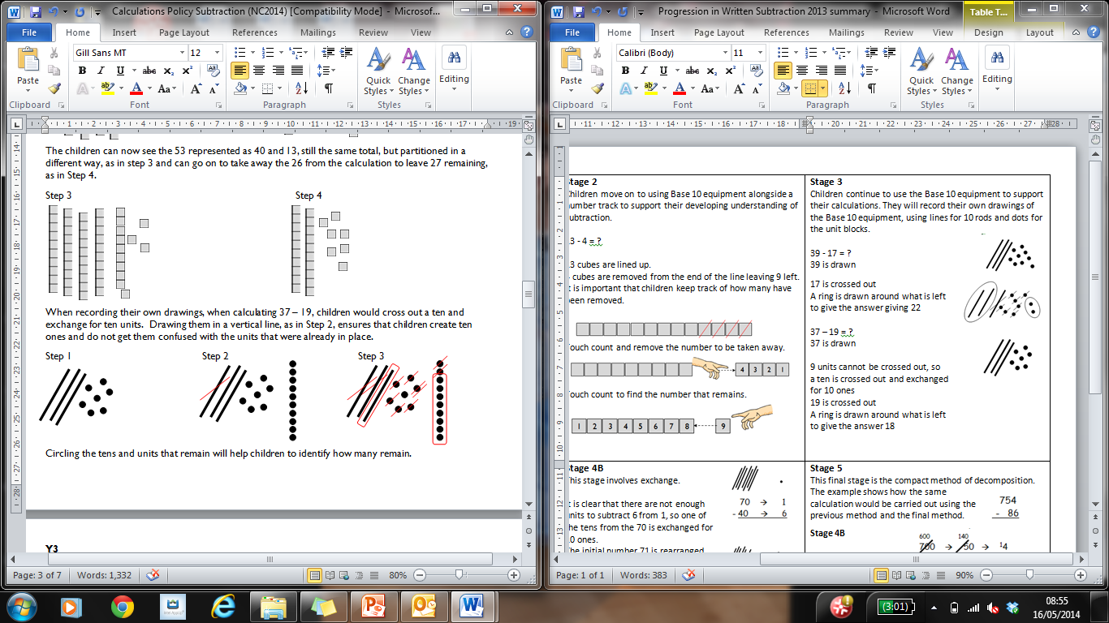  Children continue to use the Base 10 equipment and ten frames to support their calculations. They will record their own drawings of the Base 10 equipment, using lines for 10 rods and dots for the unit blocks.  39 - 17 = ?  39 is drawn  17 is crossed out  A ring is drawn around what is left to give the answer giving 22  Known as Zapping Method from Y2  37 – 19 = ?  37 is drawn  9 units cannot be crossed out, so  a ten is crossed out and exchanged  for 10 ones which are in a line.  19 is crossed out  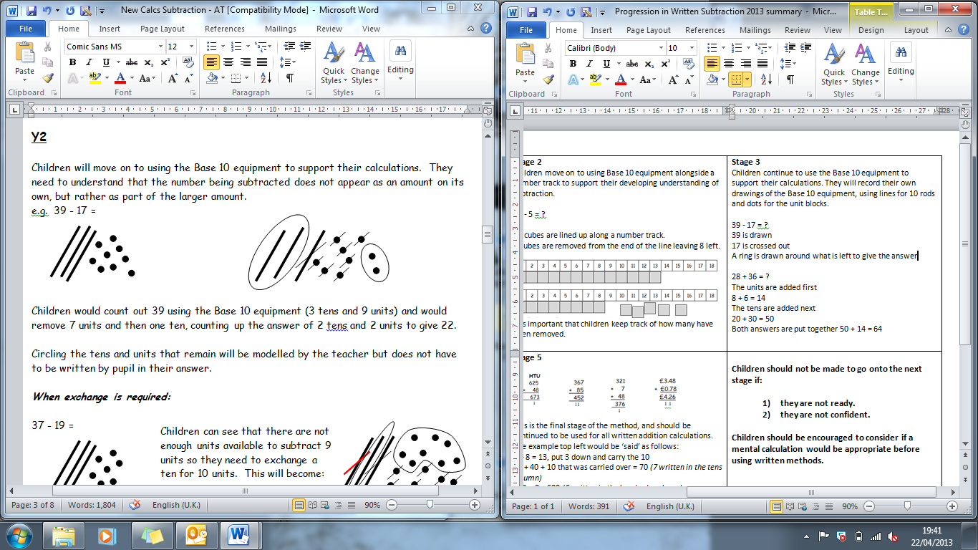  A ring is drawn around what is left  to give the answer 18  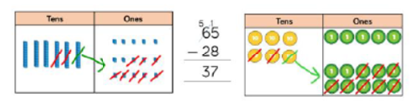
 | Stage 4A (From Y2 /Y3)  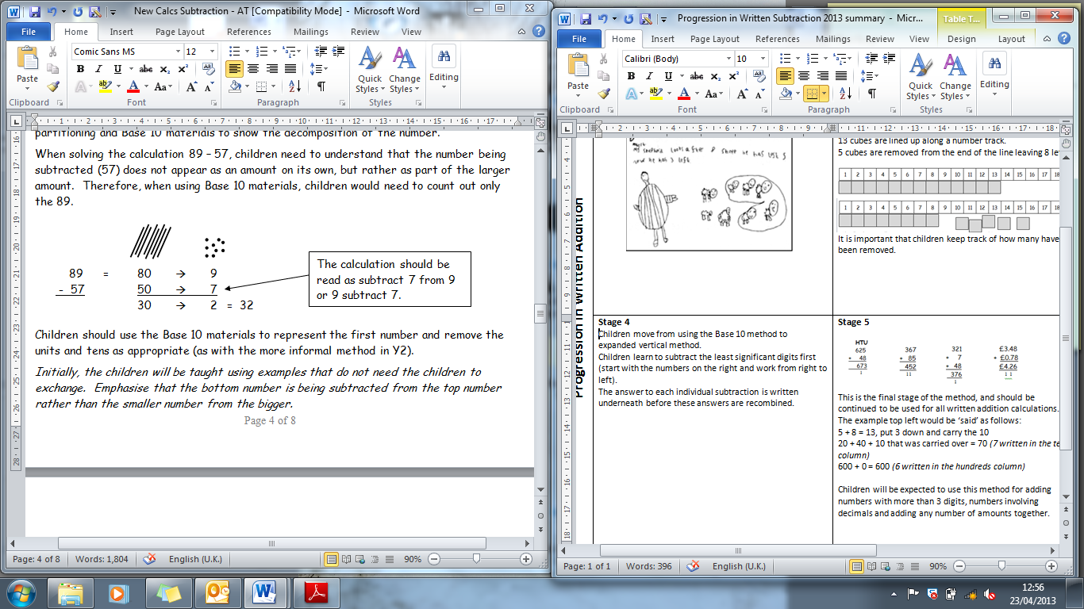  Children move from using the Base 10 method to expanded vertical method, using base 10 notation and arrow cards.  Children learn to subtract the least significant digits first (start with the numbers on the right and work from right to left).  The answer to each individual subtraction is written underneath before these answers are recombined. | Stage 4B  This stage involves exchange.  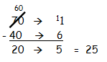  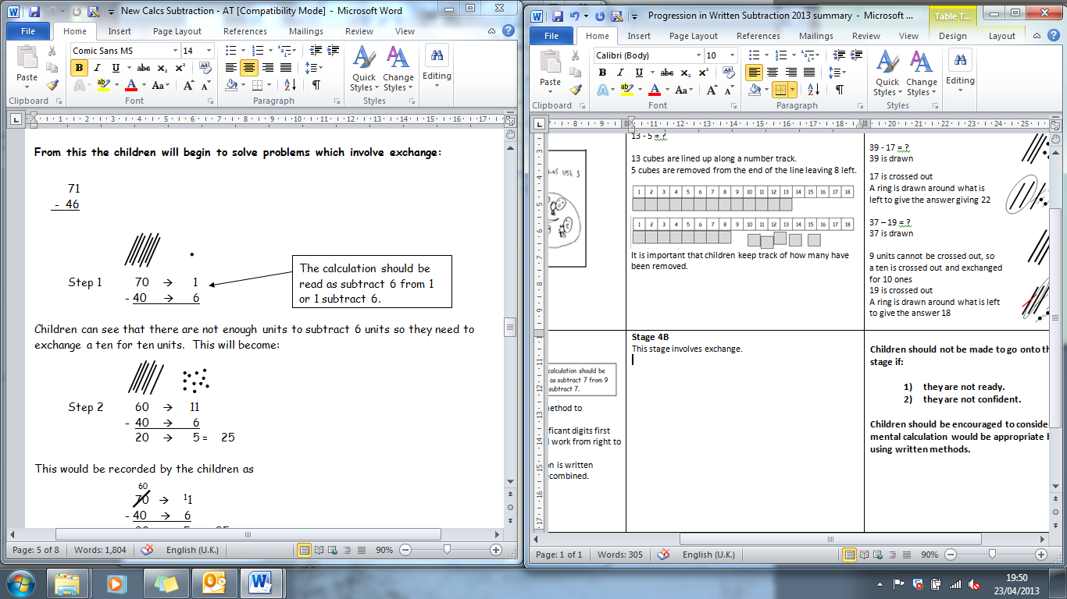  It is clear that there are not enough units to subtract 6 from 1, so one of the tens from the 70 is exchanged for 10 ones.  The initial number 71 is rearranged as 60 and 11 to make the calculation easier.  This would be recorded by the children as: | Stage 5 (From Y3 onwards)  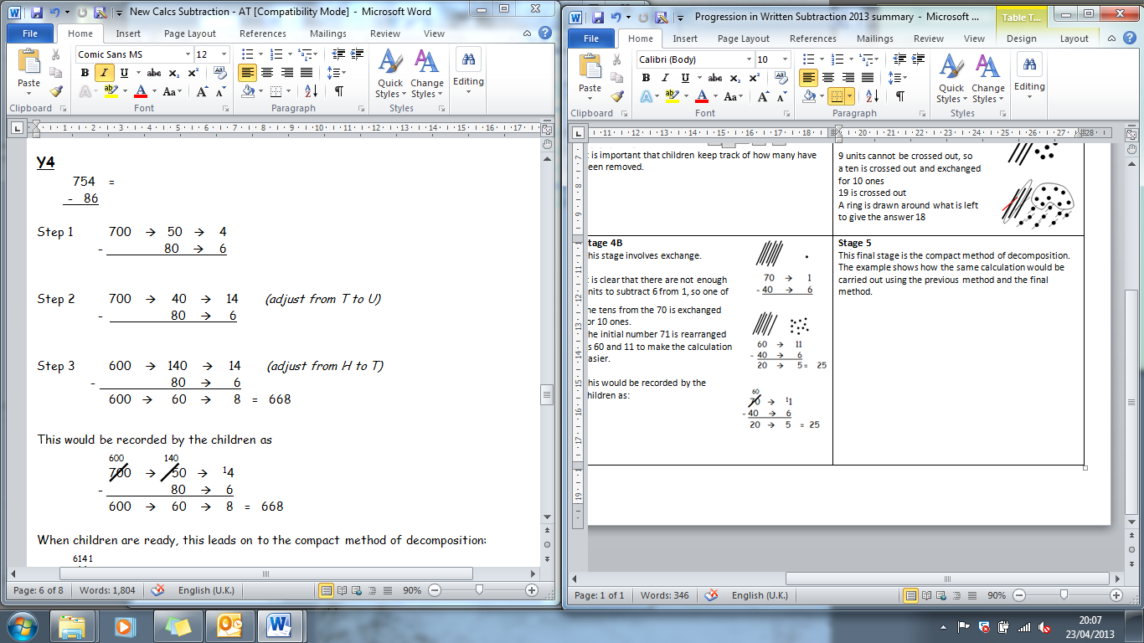  This final stage is the compact method of decomposition. The example shows how the same calculation would be carried out using the previous method and the final method.  Stage 4B  becomes  Stage 5  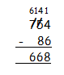  This is the final stage of the process and will continue to be used with larger numbers and numbers involving decimals.

