Butlers Hill Infant School Progression in Written Multiplication (Written in collaboration with Broomhill Junior School) | Stage 1 (From Y1)  Children are encouraged to develop a mental image of the size of numbers. They learn to think about equal groups or sets of objects in practical, real life situations.  They begin to record these situations using pictures.  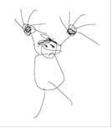  A child’s jotting showing fingers on each hand as a double.  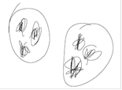  A child’s jotting showing double three as three cookies on each plate. | Stage 2 (Year 2)  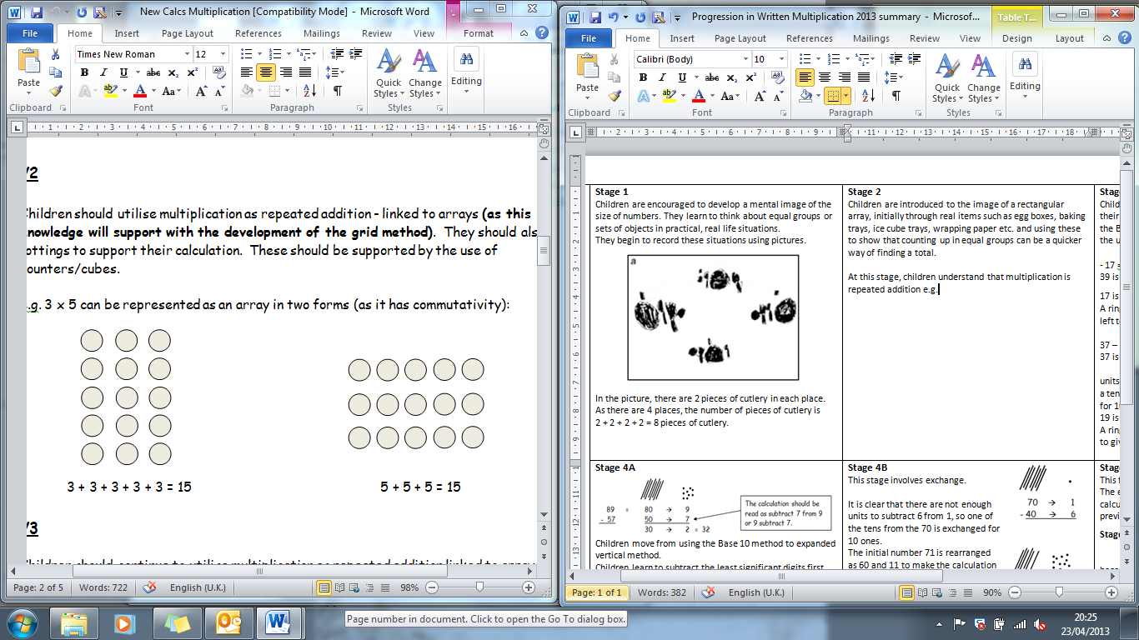  Children understand that multiplication is repeated addition and that can be done by counting in equal steps/groups.  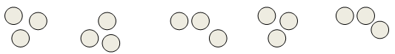  or  Children can then be introduced to the image of a rectangular array, initially through real items such as egg boxes, baking trays, ice cube trays, wrapping paper etc. and using these to show that counting up in equal groups can be a quicker way of finding a total.  Children also understand that  3 x 5 is the same as 5 x 3  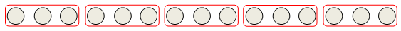 | Stage 3 (Year 2 onwards)  Children continue to use arrays and create their own to represent multiplication calculations  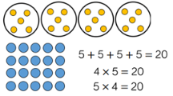  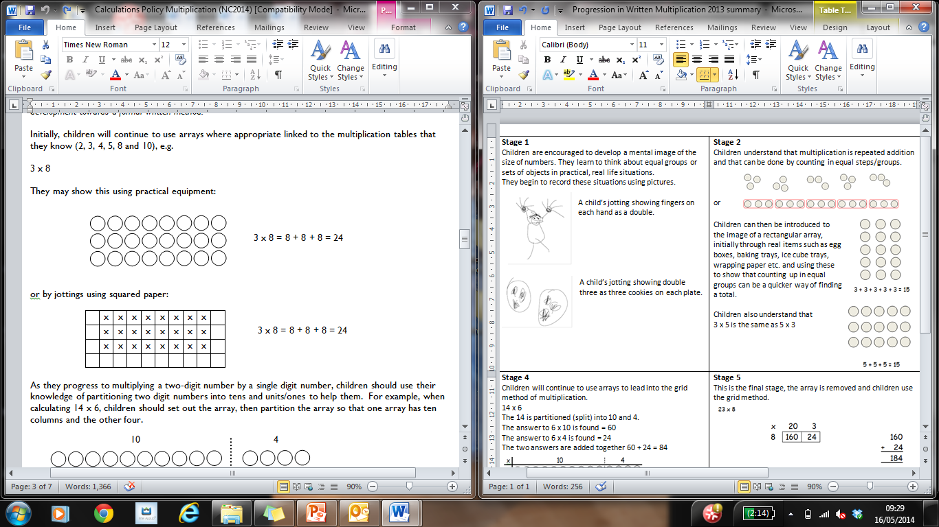
 | Stage 4  Children will continue to use arrays and move onto the expanded column method. The use of place value grids and counters is important for the children to visualise what happens.  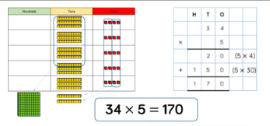 | Stage 5  In this stage, children will move on from the expanded method to the short multiplication method.  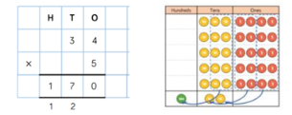  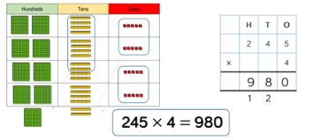 | The method in Stage 5 can be built upon for larger numbers as the children progress through Key Stage 2.  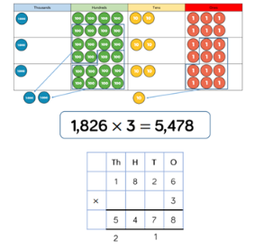  If children are multiplying larger numbers and struggling with their times tables, encourage the use of multiplication grids so children can focus on the use of the written method.
Progression in Written Multiplication | 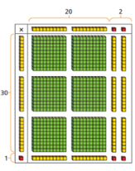  Stage 6 (From Y5)  When multiplying 2-digit numbers by 2-digit numbers, the children are taught to use the area model to help understand the size of the numbers they are using.  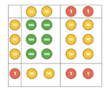  Children are then taught the grid method as this matches the area model as an initial written method.  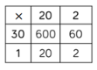 | Stage 7 (From Y5)  The grid method can then be taken into the formal written method.  The place value columns are still labelled to ensure children understand the value of each digit in the original number and the answer.  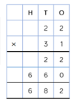 | Stage 8  The form written method method for long multiplication builds on children being efficient when using grid method.  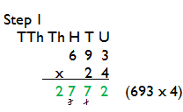  Again the place value columns are labelled to support children in understanding the value of the digits in the original numbers and in the answer.  As with other calculations,  start with the least  significant digit, which  means we are doing the  equivalent of the bottom  row of the grid method  from right to left.  Carried digits are crossed out to avoid confusion as the method continues.  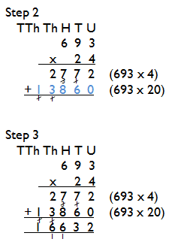  The next step is multiplying  by the multiple of 10. The  children are taught to use  the place value of the  numbers correctly.  The final step is to add the  two answers together.
Progression in Written Multiplication | Children should not be made to go onto the next stage if:  - they are not ready.  - they are not confident.  Children should be encouraged to consider if a mental calculation would be appropriate before using written methods.

