Butlers Hill Infant School Progression in Written Division (Written in collaboration with Broomhill Junior School) | Stage 1 (From Reception)  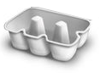  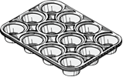  Children are encouraged to develop a mental image of the number system in their heads to use for calculation. They should experience practical calculation opportunities involving equal groups and equal sharing.  They may develop ways of recording calculations using pictures.  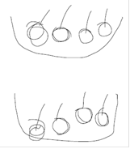  A child’s jotting showing halving six spots between two sides of a ladybird.  A child’s jotting showing how they shared the apples at snack time between two groups.  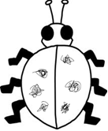 | Stage 2 (From Y1)  Children explore practical contexts where they share equally and group equally. 6 ÷ 2 = ?  Equal sharing (6 shared equally between 2)  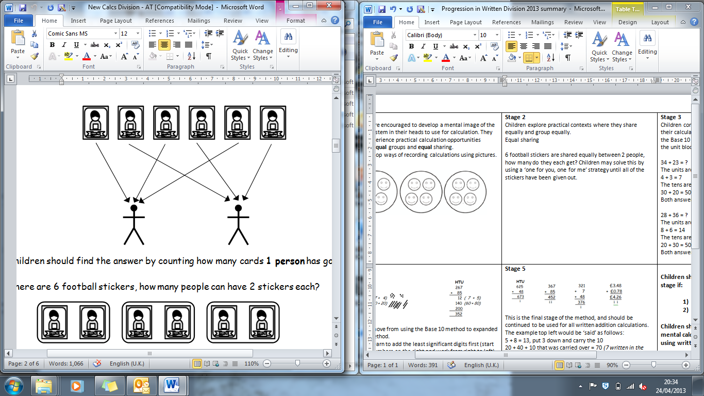  6 football stickers are shared equally between 2 people, how many do they each get? Children may solve this by using a ‘one for you, one for me’ strategy until all of the stickers have been given out.  Equal grouping (How many groups of 2 are there in 6?)  There are 6 football stickers, how many people can have 2 stickers each? | Stage 3 (From Y2)  Children continue to use practical equipment to represent division calculations as grouping (repeated subtraction) and use jottings to support their calculation.  12 ÷ 3 = ? Children begin to read this calculation as,  ‘How many groups of 3 are there in 12?’  At this stage, children will also be introduced to division calculations that result in remainders.  13 ÷ 4 = 3 remainder 1  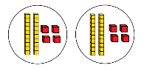  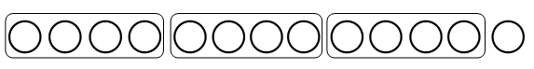  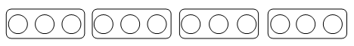
 | Stage 4 (From Y3/4)  43 ÷ 8  43 ÷ 8 = 5 remainder 3  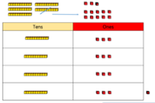  At this stage, children also learn if the remainder should be rounded up or down e.g. 62 ÷ 8 = 7 remainder 6  I have 62p. Sweets are 8p each. How many can I buy?  Answer: 7 (the remaining 6p is not enough for another sweet)  Apples are packed into boxes of 8. There are 62 apples. How many boxes do I need?  Answer: 8 (the remaining 6 apples still need to be placed into a box) | Stage 5 (From Y4)  The children use place value counters to share 2 and 3 digit numbers. The children are also taught how partitioning numbers in a part-whole model can help them.  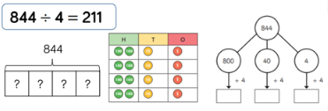 | 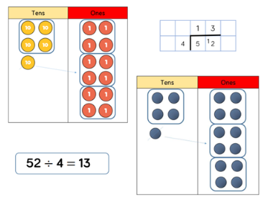  Stage 6 (From Y4/5)  The children are introduced to the grouping method to divide 2-digits by 1-digit. Children start with the largest place value and group by the divisor (the number they are dividing by).  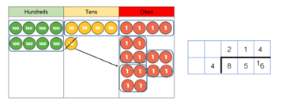  Throughout Y5, the children build on this further with dividing larger numbers.

Butlers Hill Infant School Progression in Written Division (Written in collaboration with Broomhill Junior School) | Stage 7 (From Y6)  During this stage, the children are taught how to divide larger numbers by 2-digits using the short division written method.  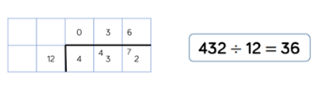  The children improve their efficiency through calculating with larger numbers. The children are encouraged to work out and record the 2-digit number calculation before solving the division.  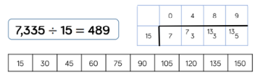 | Stage 8 (From Y6)  During this stage, the children are taught long division. We encourage the children to write out multiples (the times table) to support their calculation with the larger remainders.  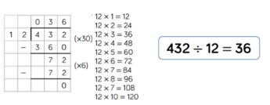
Children should not be made to go onto the next stage if:

- they are not ready.
- they are not confident.

Children should be encouraged to consider if a mental calculation would be appropriate before using written methods.

