Butler’s Hill Infant and Nursery School
Progression in Skills
Drawing, Writing, Printing, Painting, Malleable, Small World, Role Play



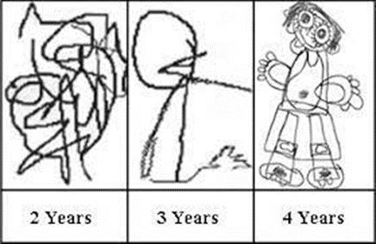
Progression in drawing
Strengthen upper body- crawl, climb, wheelbarrow, race, wash windows, fly kites, Simon says, action songs | Messy play- strengthen arms with both hands moving and squeezing | Scribbles made with lines, then lines and enclosed spaces | Finger isolation activities- finger painting, finger action songs  Pincer grip activities- peg boards, geoboards, threading
Marks including pre-writing shapes- dots, vertical lines, horizontal lines and circles | Oversimplified representation of a person | Simple representation of a person with a head, body, arms, and legs showing a range of emotions eg happy/ sad | Begin to look closely at objects, animals and people and add key features to their drawing
Marks including more complex pre-writing shapes- crosses, zig-zags, rectangles, squares and triangles | Simple pictures of familiar objects using shapes beginning to choose colours for the purpose | More detailed representation of a person | Selects colours for a purpose and use appropriate patterns when creating observational drawings of simple objects, animals and people
More complex representations of multiple objects. Colours chosen for the purpose | Create detailed observational drawings with accurate shapes, colours and patterns.

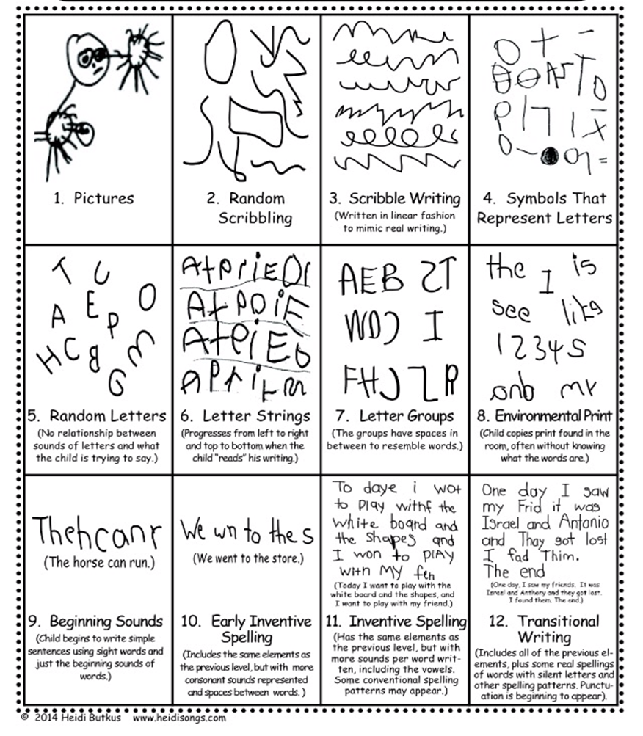
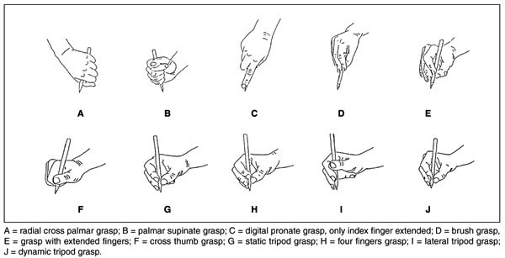
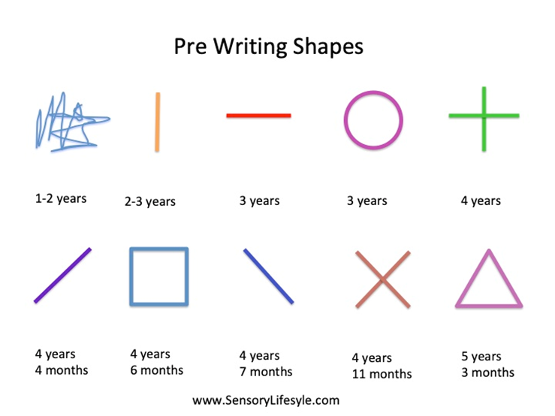

Progression in printing
Explore the marks they can make with their hands and fingers when pressing and holding them still. Name colours | Explore making marks with objects. Talk about what happens when objects are pressed, moved up and down, side to side, and twirled. Talk about what the marks look like, Name ready mix paint colours | Choose printing materials to make simple patterns | Uses printing materials to copy pictures. Chooses appropriate shapes and begins to choose colours for purpose. Uses simple forms. Begins to reflect on their ideas and talk about ways to improve.
Chooses resources to create repeating patterns. Check work with support and amend. Begin to explain their ideas to others | Use real objects as a stimulus for their artwork. Select appropriate shapes to print with. Think about the form on the page. Check work with support and amend any mistakes. | Chooses tools and resources to create patterns. Talks about their ideas, reflecting and improving their work with support. Checks their work and amends mistakes. | Use their own ideas in printing. Choose appropriate patterns or shapes for the task. Talks about their ideas, reflecting on and improving their work with support. Checks their work and amend any mistakes.

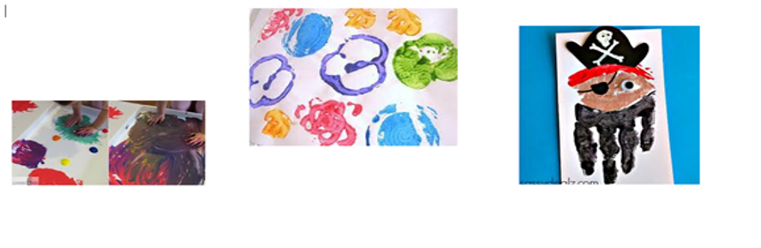
Progression in Painting
Make choices about the size and shape of the paper  Use paint brushes to make marks with ready mixed paint  Use a fist grip with both hands then move to use one hand  Make marks with the brush  Name colours | Move the brush in different ways  Press, move up and down side to side and twirl around.  Describe the marks they make  Name the colours | Make marks with various sizes of paintbrushes, sponges, rubber-tipped tools in ready mixed paint, powder paint and paint blocks. Talk about the marks made. Begin to hold smaller brushes in their fingers and thumb | Make choices about the types of marks they want to create eg dog, line, circle and which tool to use
Think of their own ideas and make marks for purpose eg circle for the head, dots for eyes. Create simple representations of objects animals and people | Use various types of paint on various textures eg tin foil, salt dough, and clay. Find the best types of paint for the task. Mix materials with paint eg sand/ glitter. Talk about their findings | Begin to add more detail to their painting selecting the correct tools for the purpose. Begin to mix colours for purpose. Talk about their work and begin to think of ways to improve | Experiment with painting techniques for a purpose eg select appropriately sized brushes, colour mixing, printing, and patterns. Explain their ideas and reflect on ways to improve
Create detailed observational paintings of objects, people and animals. Experiment with paint techniques for a purpose eg selects appropriately sized brushes, colour mixing, printing, and patterns. Explain their ideas and reflect on ways to improve | Thinks of own ideas for their artwork. Selects appropriate tools and techniques for a purpose eg selects appropriately sized brushes, colour mixing, printing, and patterns. Thinks carefully about details to enhance their artwork. Talks about their work and begins to think of ways to improve independently.

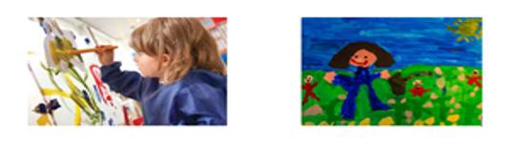
Progression in Malleable Materials
Squash- squeeze in fist Stretch- hold in both hands and pull  Pull-ups- pinch fingers and thumb upwards  Raise a cone- pinch to a point | Make models by pushing objects into the dough  Make patterns with everyday objects, wheel cutters, hammers and stamps | Roll the dough into cylinder shapes  Use knives to cut  Begin to use scissors with two hands  Roll into various-sized balls | Begin to use imagination to create simple 3D models
Make simple 3D models by joining playdough balls and adding purposeful matier seg eyes | Roll dough using various types of rolling pins.  Use scissors to cut, holding them with their finger and thumb | Make 2D shapes using cutters, adding various materials  Make other shapes using cutters and add purposeful materials eg eyes | Muscles fingers- dough on palm, push with each finger  Make it through- push a hole in dough between the thumb and each finger  Stretch the loop- place a loop of dough around four fingers, stretch fingers
Explore mark-making with more refined tools and shapes  Begin to make patterns including repeating patterns by pressing objects into the dough. | Make play dough and salt dough 2D shapes using cutters. Make patterns by pressing objects into the dough. Choose appropriate colours to paint after baking if using salt dough. | Make 2D objects with dough using various shapes.  Add purposeful materials  Press tools and objects to create texture and pattern for the dough | Make 3D models using dough  Pinch to refine shapes  Press tools and objects to create texture and pattern  Add purposeful materials and create their own eg card spikes

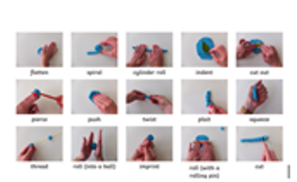
Progression in Small World Play
Participate in imaginative play | Make sounds as they participate in imaginary play. | Join in retelling a story, adding missing words | Talk about what they are doing, describe their actions and share their ideas in pretend play.
Retell simple familiar traditional stories | Talk about what they are doing describe their actions and share their ides in pretend play. Use their imagination to begin to make characters talk. | Create simple stories with characters, settings. | Retell more complex stories
Create a story with characters, setting, problems and solutions Begin to use story language. | Create a detailed story. Use story language and descriptive language.
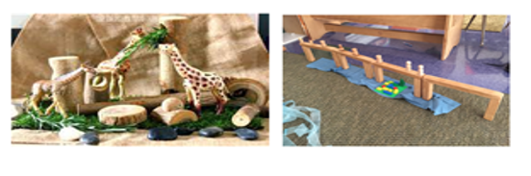

Progression in Role Play
Participate in dramatic role play | Make sounds as they participate in dramatic role play  Dress up in any costume | Use Talk for Writing to pretend to be a character and join in retelling a focus story, adding in missing words from repetitive phrases characters would say  Select masks/ costumes for a purpose | Talk about what they are doing and share ideas in domestic roleplay. Select masks/ costumes for a purpose.  Begin to use character language while pretending to be a character
Use Talk for Writing to retell a simple familiar story. Begin to build the setting.  Select masks/ costumes for a purpose.  Use character language while pretending to be a character | Talk about what they are doing, describe their actions and share ideas in imaginary role-play.  Select costumes for a purpose.  Use props provided  Use furniture to create their own setting  Use their imagination to begin to talk while pretending to be a character | Create simple stories with characters and a setting  Use resources to create their own setting and begin to create props  Select costumes for purpose  Pretend to be a character in the story | Use Talk for Writing to act out a more complex story  Create the setting and props and choose their mask/ costume  Pretend to be a character in the story
Create a detailed story with characters, setting, problem and solution. Create the setting and props and choose their costume. Pretend to be a character in the story.



