
EPU The Lighthouse planning Butler’s Hill Long Term Plan -2023-24 Dream Big, Aim High
 |  | Autumn 1 |  | Autumn 2 |  | Spring 1 |  | Spring 2 |  | Summer 1 |  | Summer2
Aims |  | The 3 C’s Caring, Creative, Confident
School/British Values |  | The 3 R’s Respect, Responsible, Resilient
Topic question |  | Where in the World am I?    I am Geographer |  | Why was the fire so Great?  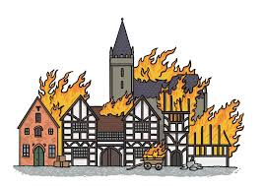  I am an Historian |  | Why save the rainforest?    I am an Eco-Warrior |  | Who was Mary Seacole?  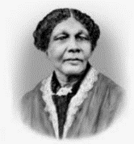  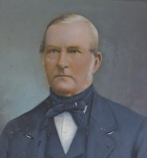  I am a nurse |  | Where will we go?  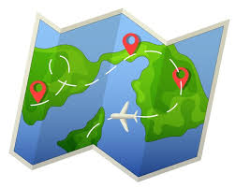  I am an Explorer |  | Could you survive Medieval Britain?  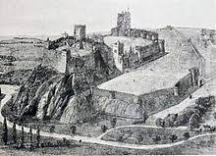  I am knight
Focus Text/Texts |  | The Gingerbread Man by Mara Alperin  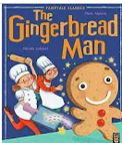 |  | Festivals by Jane Bingham  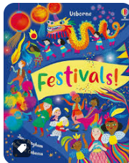 |  | A walk in the wood by Flora Martyn  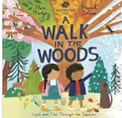 |  | The Journey Home by Emma Levay  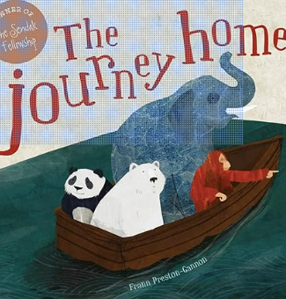 |  | Clem and the Crab by Fiona Levers  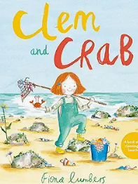 |  | Supertato by Sue Hendra?  The Secret Giant?  Even Superheroes have a Bad Day by Shelley Becker Super Duck by Jez Alborough The Gigantic Turnip by Aleksei Tolstoy and Niamh Sharkey
Additional texts |  | The Very Busy Spider Eric Carle  Dear Zoo Rod Campbell  Noisy Farm Rod Campbell |  | Stick Man By Julia Donaldson  The Very Hungry Caterpillar  Dear Santa – Rod Campbell |  | The Gruffalo – Julia Donalson  Slowly, Slowly, Slowly said the Sloth  There’s an Oran gu tan in my bedroom  Little Red Riding Hood |  | A Great Big Cuddle by Michael Rosen Hattie Peck by Emma Levey Home by Carson Ellis The Way Back Home by Oliver Jeffers |  | Kipper the Dog – the Seaside by Mick Inkpen (online story) Bonting by Shirley Hughes (in The Big Alfie Out of Doors Storybook) Seaside and Sea Sound poems by Shirley Hughes One is a Snail, Ten is a Crab by April Sayre and Jeff Sayre |  | Even Superheroes have a Bad Day by Shelley Becker Super Duck by Jez Alborough The Gigantic Turnip by Aleksei Tolstoy and Niamh Sharkey
Phonics | 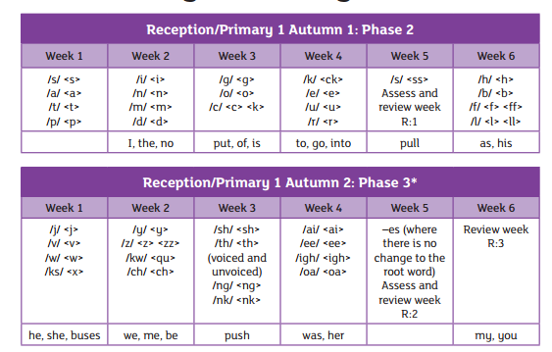 |  |  | Revisit Phase 3 week 1-3  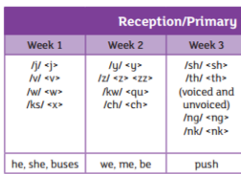 blending with Phase 2 and key words  Spring 2 Weeks 4-6  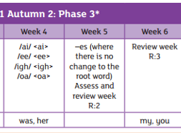Blending with Phase 3 1-3 and key words |  |  | Revisit Phase 3 weeks 4-6  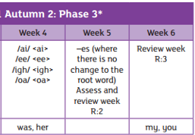  Blending with all of Phase 3 and key words
Mathematics   | Count objects, actions, and sounds.  Subitise  Matching. Sorting & Comparing  Comparing amounts  Comparing size, mass & capacity Exploring pattern - making simple. | Explore the composition of numbers to 10  Subitise  Automatic recall number bonds 0-10 |  | Explore the composition of numbers to 10  Subitise  Automatic recall number bonds 0-10 |  | Explore the composition of numbers to 10  Subitise  Automatic recall number bonds 0-10  Numbers 7, 8, 9  Making pairs.  Combining groups  Number bonds  3D shapes  Pattern. | Explore the composition of numbers beyond 10.  Subitise  Automatic recall number bonds 0-10  Number 10 and beyond– subitising, counting, sorting, matching, comparing, ordering  Composition of numbers to 10 and beyond  Counting patterns to 10 and beyond  Spatial reasoning.  3D shape  Match, rotate, and manipulate  Pattern – AABB, BBA  Sunflower Challenge | Explore the composition of numbers beyond 10.  Subitise  Automatic recall number bonds 0-10
 |  | Representing 1,2,3  Comparing 1,2,3  Composition of 1,2,3  Formation of 1,2,3  Circles and triangles  Positional language | Representing 4,5  Comparing 4,5  Composition of 4,5  Formation of 4,5  One more and less  Shapes with 4 sides.  Time | Introducing zero  Comparing numbers to 5  Composition of 5  Comparing Mass  Comparing Capacity | Number 6, 7, 8  Making pairs, pairs wise, doubles  Combining 2 groups  Length, height.  Time |  |  | Adding more  Taking away  Number bonds  Shape – spatial reasoning | Doubling  Sharing and grouping  Even and odd  Patterns and relationships
Ongoing throughout the year | Daily Maths games in CP to consolidate no recognition counting forwards and backwards, dice patterns, subitising. 1:1 counting

Key Events | Harvest Festival |  | Bonfire Night  Remembrance Day  Children In Need  Anti-Bullying Week |  | Internet Safety Day |  | World Book Day  Comic/Sports Relief |  | Healthy Living Week |  | Transition Day
History Year 2 adapted |  |  | The Great Fire of London |  |  |  | Mary Seacole Hospitals in the past |  |  |  | Medieval Britain
Geography Year 2 adapted | The UK  Continents and Oceans |  |  |  | Locations and climates of Rainforests |  |  |  | Mapwork of local area  Compare local area to coast
Music  Charanga  Most children with own class  Anyone Can play SEND scheme | Introducing Instruments |  | Exploring Instruments |  | Choosing instruments |  | Introducing Sway |  | Introducing March |  | Introducing Loud and Quiet
ICT
ALL in own classrooms
Art/Design  In own classes  In continuous Provision | Baking – Make gingerbread men |  | Box modelling of houses/streets |  | Make a layered rainforest |  |  |  |  |  | Make a castle
Forest School  Link to Maths/Science |  |  |  |  | A Walk in in the Woods text  Minibeast/woodland habitat |  |  |  | Planting |  | Growing
Science  White Rose Maths | Animals needs for Survival |  | Humans/Plants light and dark |  | Habitats |  | Materials |  | Bulbs and Seeds |  | Growing
RE -Year 2 | Leaders |  | Story |  | Stories from the Torah |  | Believing |  | Belonging
PHSE/SRE – | Belonging to a class  Who can help me?  Who can I trust? |  | Being a friend  Personal space  Kindness  Taking turns |  | Learning to regulate and identify emotions |  | Learning to regulate and identify emotions |  | Learning to regulate and identify emotions |  | Transition/Change

 | Re-read books to build up their confidence in word reading, their fluency and their understanding and enjoyment. Read books consistent with their phonic knowledge.
Phonics |  |  |  | 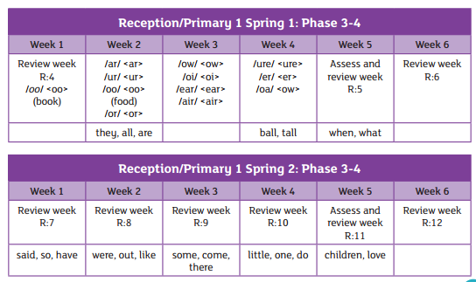 |  |  | 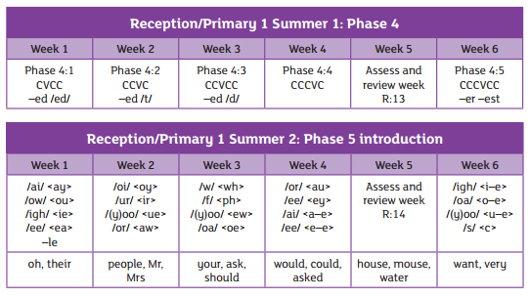
Mathematics | Count objects, actions, and sounds.  Subitise  Matching. Sorting & Comparing  Comparing amounts  Comparing size, mass & capacity Exploring pattern - making simple. | Explore the composition of numbers to 10  Subitise  Automatic recall number bonds 0-10 |  | Explore the composition of numbers to 10  Subitise  Automatic recall number bonds 0-10 |  | Explore the composition of numbers to 10  Subitise  Automatic recall number bonds 0-10  Numbers 7, 8, 9  Making pairs.  Combining groups  Number bonds  3D shapes  Pattern. | Explore the composition of numbers beyond 10.  Subitise  Automatic recall number bonds 0-10  Number 10 and beyond– subitising, counting, sorting, matching, comparing, ordering  Composition of numbers to 10 and beyond  Counting patterns to 10 and beyond  Spatial reasoning.  3D shape  Match, rotate, and manipulate  Pattern – AABB, BBA  Sunflower Challenge | Explore the composition of numbers beyond 10.  Subitise  Automatic recall number bonds 0-10
 |  | Representing 1,2,3  Comparing 1,2,3  Composition of 1,2,3  Formation of 1,2,3  Circles and triangles  Positional language | Representing 4,5  Comparing 4,5  Composition of 4,5  Formation of 4,5  One more and less  Shapes with 4 sides.  Time | Introducing zero  Comparing numbers to 5  Composition of 5  Comparing Mass  Comparing Capacity | Number 6, 7, 8  Making pairs, pairs wise, doubles  Combining 2 groups  Length, height.  Time |  |  | Adding more  Taking away  Number bonds  Shape – spatial reasoning | Doubling  Sharing and grouping  Even and odd  Patterns and relationships
Ongoing throughout the year | Link the number symbol with its cardinal number value. Select, rotate, and manipulate shapes to develop spatial reasoning skills.  Count beyond ten. Compare numbers Compose and decompose shapes so that children recognise a shape can have other shapes within it, just as numbers can.  Understand the ‘one more/one less than’ relationship between consecutive numbers. Continue, copy, and create repeating patterns.  Compare length, weight, and capacity.

