
Butler’s Hill EYFS Medium Term Plan
Dream Big, Aim High
2026-27 Autumn 1
 | Nursery | Reception
Growth Mindset (linking characteristics of effective learning) | Have a go: Engaging in new experiences and initiating learning behaviours  (Playing and Exploring: willing to have a go, curiosity) | Try new things independently: Initiating learning and selecting appropriate resources independently  (Playing and Exploring: willing to have a go, curiosity)
Focus Text/Texts | 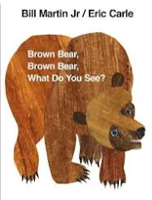  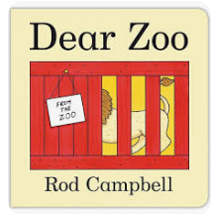  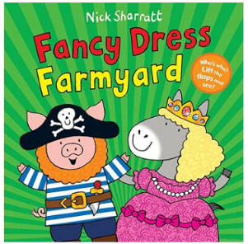  Repetitive language Repetitive and predictable Poetry and animal week | Following Pathways Literacy Scheme  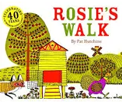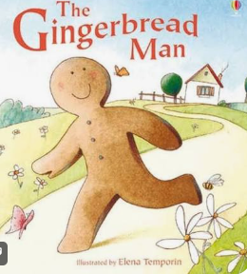
Reading Spine Books | Enhance reading experience: Hug by Jez Alborough | 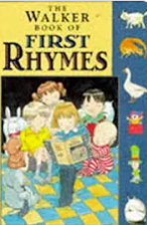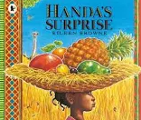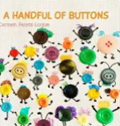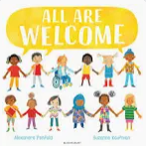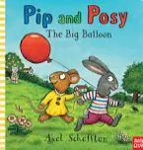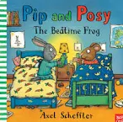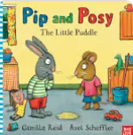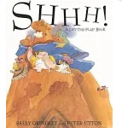
Fairytale story | Chicken Licken – repetitive journeys  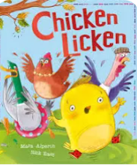 | The Gingerbread Man – repetitive journeys
Nursery rhymes | Simple, repetitive, action-based:  Twinkle Twinkle Little Star  Incy Wincy Spider  Five Little Ducks  Old MacDonald Had a Farm  Humpty Dumpty  Baa Baa Black Sheep | Pulse → rhythm → pitch → performance  Pat-a-Cake  1,2,3,4,5 Once I Caught a Fish Alive  This Old Man  Five Little Ducks  Twinkle Twinkle Little Star  Incy Wincy Spider
Protected Characteristics | William’s Doll – Shows a boy playing with dolls, challenging stereotypes.  My Princess Boy – Supports gender expression outside norms.  Pink Is for Boys – Challenges colour/gender assumptions.  LINK: PSED – Self-Regulation: Expresses preferences and feelings. & Building Relationships: Plays cooperatively.  *** Does this need changing in line with whole school overview. | Age, disability, race, sex  We are all different; everyone belongs; families and people may look, move, communicate and play differently. We treat everyone with kindness and respect.  All Are Welcome – Alexandra Penfold
Protected Characteristics | Children are not taught the term “protected characteristics.” These are used by adults to plan inclusive experiences that promote belonging, respect, and positive mental wellbeing.
British Value | Rule of Law:  Maisy Goes to Preschool, Lucy Cousins - Maisy follows classroom routines like sharing and tidying up, showing how rules help everyone have a good day.  No, David! David Shannon - David learns that rules help keep everyone safe and happy. Children see that rules are important and help us live together. | Rule of Law- following rules  Democracy- Voting for school councillors
CLL Focus | Listening  * Listen Buddy, Helen Lester (listening to instructions link)  * Why Should I Listen?, Claire Llewellyn (importance of listening safety link) | Listening  Introduce how to be a good listener  Give me 5
Executive Functioning Focus | Have a go- Engaging in new experiences and initiating learning behaviours  Playing and Exploring | Try new things independently  - Initiating learning and selecting appropriate resources independently  Playing and Exploring
Key Events | * Harvest Festival | * Harvest Festival
Key Dates | 16th September: World Clean-up Day  21st September: Peace Day – promoting ‘be kind’ rule in Nursery  26th September – European day of languages – promoting linguistic diversity & acceptance.  1st October – Poetry day – promoting language and sound play  (2nd October – grandparents day)  4th October – world animal day – promoting care and kindness to animals/ pets  5th – 11th October - Library week- promoting love of reading, libraries and language  10th October – World Mental Health Day – promoting positive mindset, kindness, awareness of healthy minds  14th October – Black and orange day  23rd October (TBC) – Harvest

Area of Learning | Nursery | Reception
Communication and Language   | Listening, attention and understanding  Baseline:  Listen to other people’s talk with interest, but can easily be distracted by other things.  Listen to simple stories with interest.  Understand simple instructions like “give to mummy” or “stop”.  By 3 yrs of age can the child shift from one task to another if you get their attention. (Using a child’s name can help).  December:  Get their attention by using their name  Listen and respond to a simple instruction with 3 key words.  Listen to simple stories and understand what is happening, with the help of the pictures.  Identify familiar objects and properties for practitioners when they are described. For example: ‘Katie’s coat’, ‘blue car’, ‘shiny apple’.  Can find it difficult to pay attention to more than one thing at a time.  Listen during small group activities.  Speaking  Baseline:  Use the speech sounds p, b, m, w.  Links 3 or more words.  December:  Start to say how they are feeling, using words as well as actions.  Start to develop conversation, often jumping from topic to topic.  Develop pretend play: ‘putting the baby to sleep’ or ‘driving the car to the shops’.  Links 3-4 words. | Listening, attention and understanding  End Aut 1:  Listens for short periods with adult support.  Begins to comment on familiar topics with adult support.  Begins to answer questions and respond in short exchanges.  Speaking  End Aut 1:  Joins in with short contributions with adult support.  Offers simple explanations with adult support using recently introduced vocabulary.  Begins to express ideas in short sentences with adult modelling.  PATHWAYS LITERACY SCHEME:  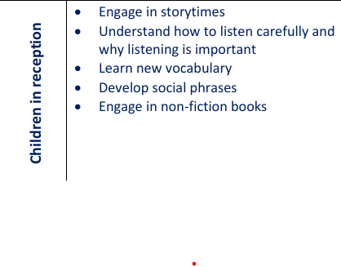
Personal, Social and Emotional Development  Self-regulation   | Self regulation  Baseline:  Feel confident when exploring the Nursery setting. When there is a familiar person nearby  Feel confident enough to express a range of emotions  Find ways of managing transitions, for example from their parent to their key person.  December:  Express preferences and decisions. They also try new things and start establishing their autonomy.  - Become more outgoing with unfamiliar people, in the safe context of their setting.  Talk about their feelings using words like ‘happy’, ‘sad’, ‘angry’ or ‘worried’  Managing Self  Baseline:  Shows an awareness of what a toilet is used for.  Communicates their need for the toilet.  December:  Begin to show ‘effortful control’. For example, waiting for a turn and resisting the strong impulse to grab what they want or push their way to the front.  Meets their own care needs with help e.g using the toilet, washing and drying their hands thoroughly.  Building Relationships  Baseline:  Seeks comfort from a familiar adult when needed.  Play with increasing confidence on their own, because they know their key person is nearby and available  December:  Play with increasing confidence on their own and with other children, because they know their key person is nearby and available  JIGSAW SCHEME: Being me in my world  'Who am I and how do I fit?'  - Belonging  - Kindness  - Feelings  - Rules of Nursery | Self regulation  Recognises and names basic emotions in themselves.  Seeks adult support when upset.  Begins to engage with short, adult-led tasks and routines.  Responds to name and attends briefly to adult voice. Follows simple one-step instructions with support.  Managing Self  Will try new activities with adult encouragement. Begins to explore independently.  Begins to follow simple rules with reminders.  Begins to manage personal needs with adult support.  Talk with others to solve conflicts.  Begin to develop the skills they need to manage the school day successfully:  lining up and queuing, mealtimes, personal hygiene  Building Relationships  Begins to play alongside others with adult support.  Begins to form secure attachments with familiar adults.  Begins to recognise own needs and seek support.  Healthy Living Focus - * Personal self-care – toileting & hand washing  JIGSAW SCHEME: Being me in my world  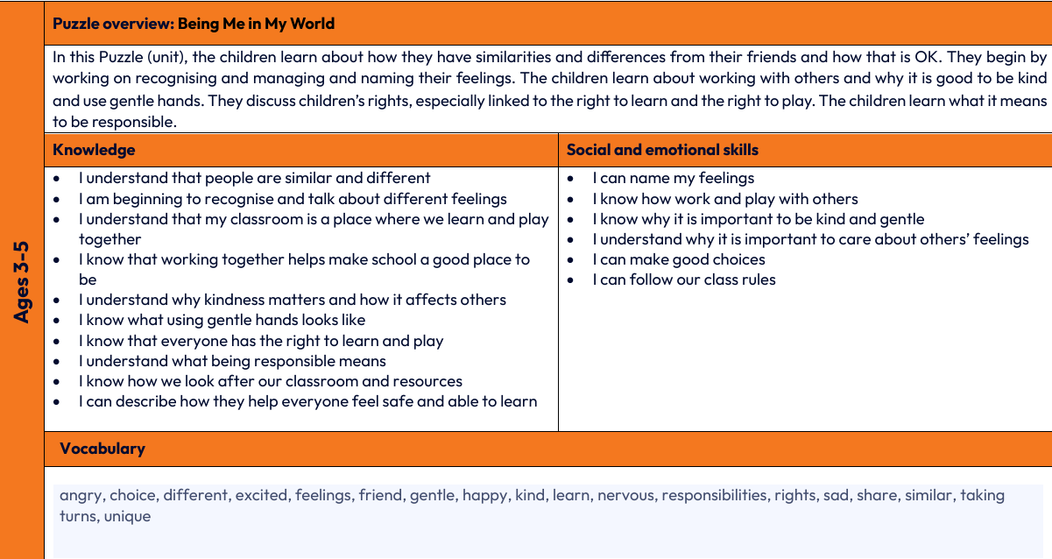
Religious Education and Worldviews | At this stage (EYFS Development Matters/Birth to 5 Matters), learning aligns primarily with Personal, Social and Emotional Development (PSED) and Understanding the World (UtW). Centring on personal identity, belonging, community, and exploring celebrations through stories, play, and sensory experience.  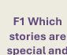  This half term focus:  Recognises self and immediate family; identifies as a valued member of the nursery class.  - Belonging (family, Nursery, keyworker group)  - Feelings  - Family | Reception RE – F5: Belonging  Topic: Settling in, families, getting to know children, belonging and different families.  Learning objectives  By the end of the unit, children should be able to:  - Develop a sense of belonging within their class, school and wider community.  - Talk about themselves and their families, sharing experiences, interests and things that are important to them.  - Recognise that families can be different, understanding that families may look different and live in different ways.  - Understand that people belong to different groups, such as families, friendship groups, school communities and religious communities.  - Begin to explore religious belonging, recognising that some children and families belong to a religious community.  - Recognise ways people welcome and celebrate new members of a family or community, including baby-welcoming ceremonies.  - Develop kindness, respect and a sense of inclusion, recognising that everyone is important and belongs in different ways.
Physical Development   | Gross Motor  Baseline:  Begins to walk and run with control  Begins to jump and climb with adult support  Sit on a push-along wheeled toy  Uses large-muscle movements to wave flags and streamers  December:  Spin, roll and independently use ropes and swings (for example, tyre swings).  Build independently with a range of appropriate resources.  Walk, run, jump and climb – and start to use the stairs independently.  Puts on own coat with support.  Uses large-muscle movements to paint and make marks. | Gross Motor  Shows basic awareness of space and obstacles with adult guidance.  Shows emerging balance and coordination with support.  Moves with some energy in familiar activities with adult support.  ‘GET SET FOR PE’ SCHEME:  Introduction to PE UNIT 2  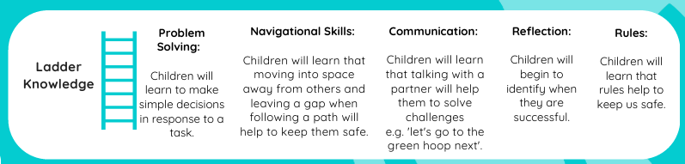
 | Fine motor  Baseline:  Beginning to balance blocks to build a small tower  Uses a fisted or palmer grasp to make marks  Start to eat independently  December:  Begins to move away from a fisted to a palmer or five finger grasp.  Beginning to show a preference for a dominant hand.  Develop manipulation and control and explore different materials and tools. | Fine motor  Uses a five finger grasp but begins to use a more refined grip with adult support.  Puts on own shoes with support  Begins to hold and use small tools with adult support.  Makes purposeful marks with emerging control
Literacy  (Comprehension)   | Comprehension  Baseline:  Join in with songs and rhymes, copying sounds, rhythms, tunes and tempo.  Say some of the words in songs and rhymes.  Pay attention and respond to the pictures or the words in book when listening to story.  December:  Sing songs and say rhymes independently, for example, singing whilst playing.  Repeat words and phrases from familiar stories.  Develop play around favourite stories using props. | Comprehension  Know that a text has key points.  Can predict what might happen next.  Listens attentively to stories and responds verbally or through actions, showing awareness of characters or repeated phrases.  Shows awareness of familiar stories and reacts to repeated events as they occur.  Shows understanding of new vocabulary when supported by an adult.
Literacy  (Word Reading) | Word Reading  Baseline:  Beginning to show interest in print  December:  Notice some print, such as the first letter of their name or a bus or door number. | Word Reading  Says the sound for taught letters of the alphabet when prompted.  Can blend 2–3 sounds in familiar words with adult support.  Can orally blend at least 5 words  Reads simple captions with support, using phonic knowledge to decode words.  PATHWAYS LITERACY SCHEME:  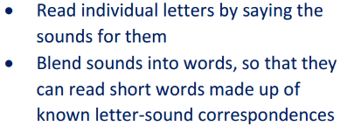
Phonics | Phonics  Baseline:  Listening and attention focus  Environmental & instrumental sounds  December:  Speech detection | Phonics  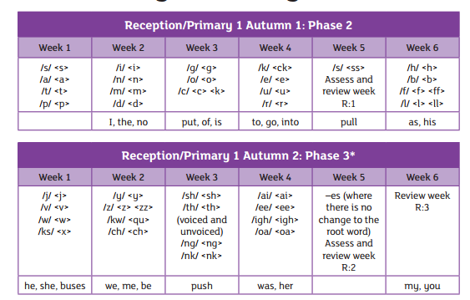
Literacy  (writing) | Writing  Baseline:  Enjoy drawing freely.  Beginning to add some marks to their drawings, which they sometimes give meaning to. For example: “That says mummy.”  Scribbles begin to become more controlled  Can form Pre-writing shapes appropriate to their age  December:  Add some marks to their drawings, which they give meaning to  Enjoys mark making for a purpose.  Can form Pre-writing shapes appropriate to their age | Writing  - Can form Pre-writing shapes appropriate to their age  - Writes some letters correctly when guided or modelled.  - Writes some letters to represent the initial sounds of words.  - Writes simple letters, words or phrases that can sometimes be read by others  - Writes some or all of their name (PTW)  WRITING ASSESSMENT- ARE Initial sounds  PATHWAYS LITERACY SCHEME:  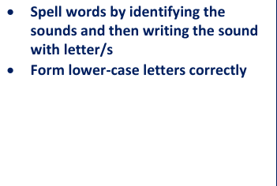
Handwriting | Handwriting  Prewriting patterns (Focusing on gross motor)  Baseline:  Vertical and horizontal lines  December:  Circles | Handwriting:  Pre writing shapes assessment- Baseline and End Autumn 1  Pencil Grip assessment: Baseline and End Autumn 1  Squiggle Moves:  -Up, Down, Up & Down, Side- to side/crossing the midline  -Wiggle  -Circles  -Humps  - Hooks
Maths   | Number  Baseline:  Take part in finger rhymes with numbers.  December:  Recite numbers to 5.  Begins to show ‘finger numbers’ up to 5.  Link numerals and amounts to 1.  Numerical patterns  Baseline:  Notice patterns and arrange things in patterns  December:  Begins to organise and categorise objects into separate piles  Shape, Space & Measure  Baseline:  Complete inset puzzles.  December:  Understand position through words alone – for example, “The bag is under the table,” – with no pointing.  Understands the concept of big and small.  Talk about and identify the patterns around them. For example: stripes on clothes, designs on rugs and wallpaper. Use informal language like ‘pointy’, ‘spotty’, ‘blobs’ etc. | Number  - subitise to 3  - show 1,2, 3 on fingers  - find one more or less to 3  represent 3 using numerals and objects  Numerical patterns  Sort and match objects using routines, tidy time etc  Understand a set or collection  Use more to describe a set  Shape, Space & Measure  name circle and triangle
Ongoing throughout the year | Subitising  Simple 2D shapes – mathematical language, matching, drawing,  Positional language
Understanding the World   | Past and Present  Baseline:  Knows and talks about their immediate family.  December:  Begin to make sense of their own life-story and family’s history.  Understands cause and effect.  People, Culture & Communities  Baseline:  Establishes sense of self.  Talk about members of their immediate family.  December:  Make connections between the features of their family and other families.  Notice differences between people  The Natural World  Baseline:  Explore natural materials, indoors and outside.  Explore materials with different properties (and name some of them).December:  Use all their senses in hands-on exploration of natural materials and some words to describe them.  Explore and respond to different natural phenomena in their setting and on trips. | Past and Present  Talks about familiar people and what they do in simple terms.  Talks about recent past events in relation to their own experiences.  Talks about characters and settings in stories using simple language.  People, Culture & Communities  Describes features of the immediate environment using simple language.  Talks about own family routines or celebrations.  Describes familiar aspects of life in this country.  The Natural World  Makes simple observations about animals and plants.  Talks about own family routines or celebrations.  Describes familiar aspects of life in this country.
Expressive Arts and Design   | Creating with Materials  Baseline:  Experiment with marks and begin to distinguish between the different marks they make.  Explore paint, using fingers and other parts of their bodies as well as brushes and other tools.  December:  Use their imagination as they consider what they can do with different materials.  Join different materials and explore different textures.  Being Imaginative and Expressive  Baseline:  Enjoy and take part in action songs, such as ‘Twinkle, Twinkle Little Star’.  - Start to develop pretend play, pretending that one object represents another. For example, a child holds a wooden block to her ear and pretends it’s a phone.  Explore a range of sound-makers and instruments and play them in different ways.  December:  Respond emotionally and physically to music when it changes.  Remember and sing entire songs (simple) and/ or Nursery rhymes.  Verbally take part in pretend play. | Creating with Materials  Explores a variety of materials using senses and uses tools safely with guidance.  Shares creations with an adult and gives simple comments about what they have done.  Uses props in simple role play linked to familiar experiences.  Being Imaginative and Expressive  - Joins in with repeated phrases and actions from familiar stories.  Joins in with familiar rhymes and songs using simple words.  Joins in short songs, rhymes or stories with adult support; begins simple movement in time with music.

